PathTrak 4.5 Release Notes

PathTrak
Version 4.5

Jan 31, 2017

Contents
Summary of PathTrak 4.5 Changes 2
PathTrak Downstream Monitor 3
Enhanced Data Content in MACTrak Alarming SNMP Trap 8
Enterprise Server Support 8
Automated CPE-CM MAC Mapping For MACTrak 8
Direct Access Architecture (DAA) Spectrum Analysis Support 8
Windows 2016 Server Support 9
3rd Party Software Updates 9
Adjustable MACTrak Alarming Trigger Intervals 10
MACTrak Mobile 12
Other Corrections/Enhancements 14
Reference Material/URL’s 15

Summary of PathTrak 4.5 Changes

- PathTrak Downstream Monitor (PathTrak PNM extension)
- Enhanced Data Content in MACTrak Alarming SNMP Trap
- Enterprise Server Support
- Automated MACTrak CPE-CM MAC Mapping
- DAA Spectrum Analysis Support
- Windows 2016 Server Support
- 3rd Party Security Updates (Java/MySQL)

PathTrak Downstream Monitor
PathTrak Downstream Monitor converts raw downstream spectrum data from compatible full-band capture CPE into actionable information about overall HFC plant health.
PathTrak Downstream Monitor is an extension to existing PathTrak PNM capabilities. All compatible CPE licensed for PathTrak PNM will have these new capabilities enabled upon installation of PathTrak 4.5 server software.
Key Points: Automated Downstream Analysis Capabilities
- Auto-Discover Capable CPE
- Scheduled Automated Polling
- Auto-Recognition of Common Symptoms
- Mapping of Categorized Results

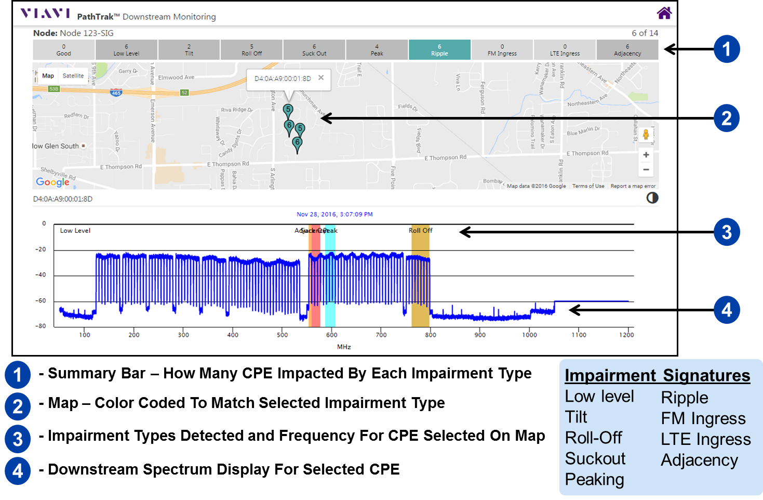
Figure 1 – Screenshot showing PathTrak Downstream Monitor user interface

Implementation Details:
- MUST have correct read only AND read/write SNMP community strings for the modems for Full-Band Capture (FBC) capable D3 modems only
- MUST have valid PNM license and PNM set up and working
- SNMP community strings for both PNM and Downstream FBC can be set here:
- To access the downstream full band capture spectrum data, launch Downstream Node Details from here
- This will launch the Downstream Node Details page that includes every node that is part of the PNM set up
- This page can take a while to load with a lot of nodes
- Columns are sortable and can be switched on or off
- Data can be exported to .csv or .pdf
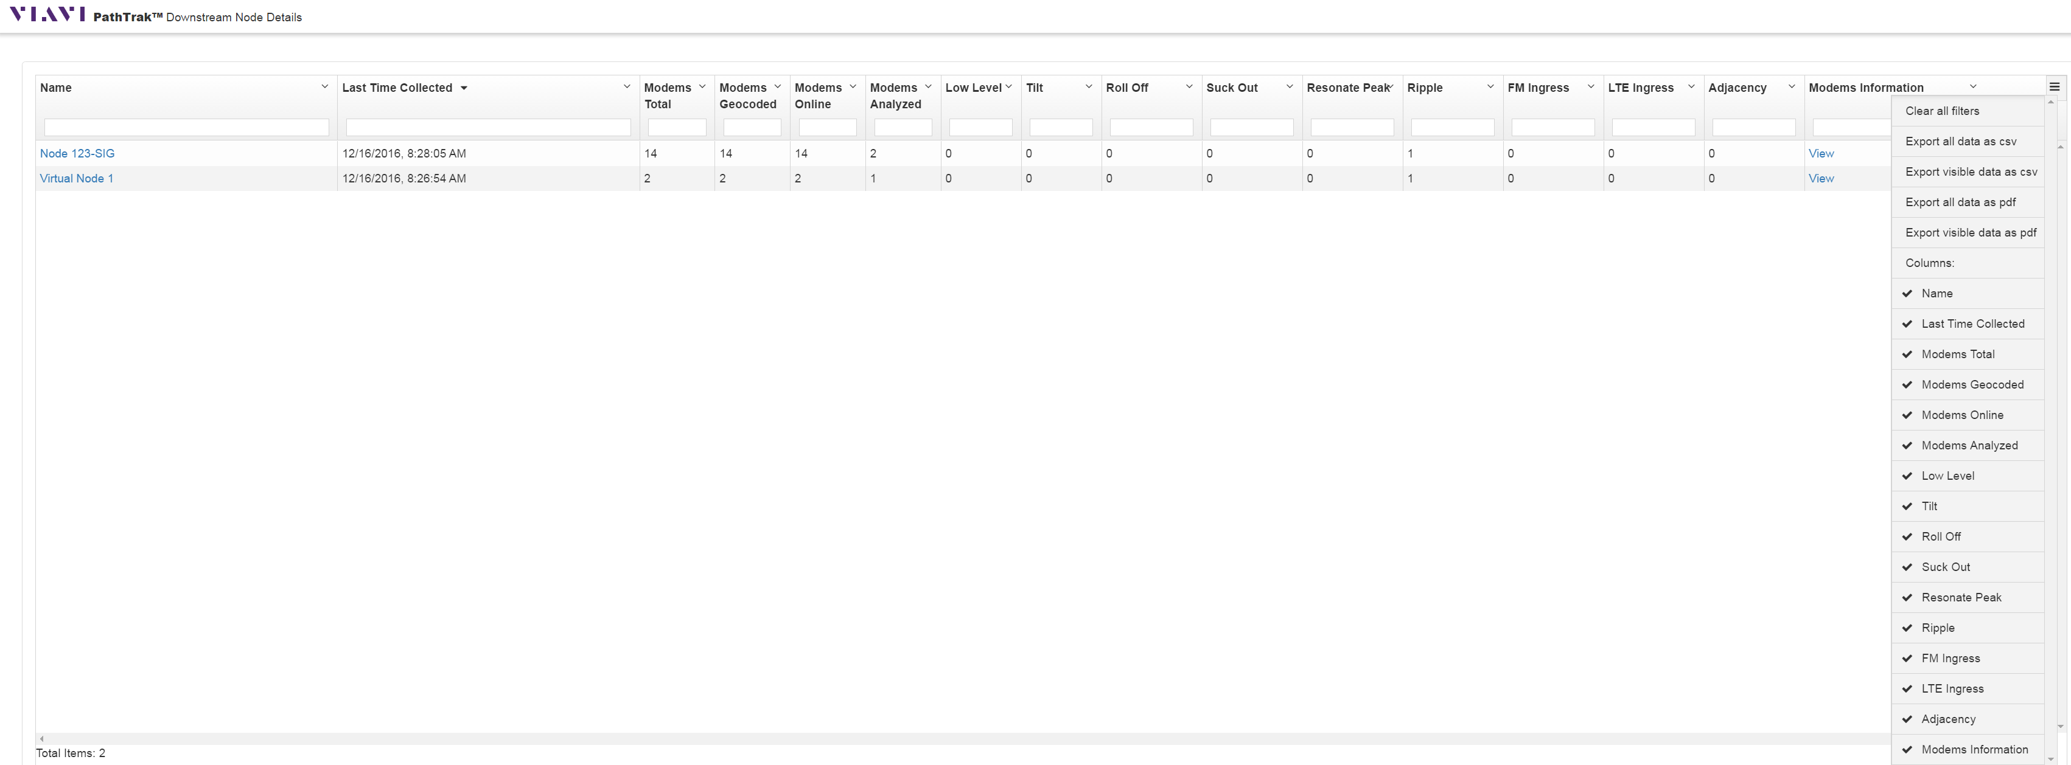
- Each node name is a URL that when clicked, if the modems analyzed column is greater than zero, will launch the downstream full band capture impairment characterization and correlation map
- The impairments detected are listed across the top and are color coded
- Clicking on a modem “pushpin” will launch the FBC spectrum stored in cache from the last time we polled that modem
- Final release notes will have more details on this page
  - Description of each column

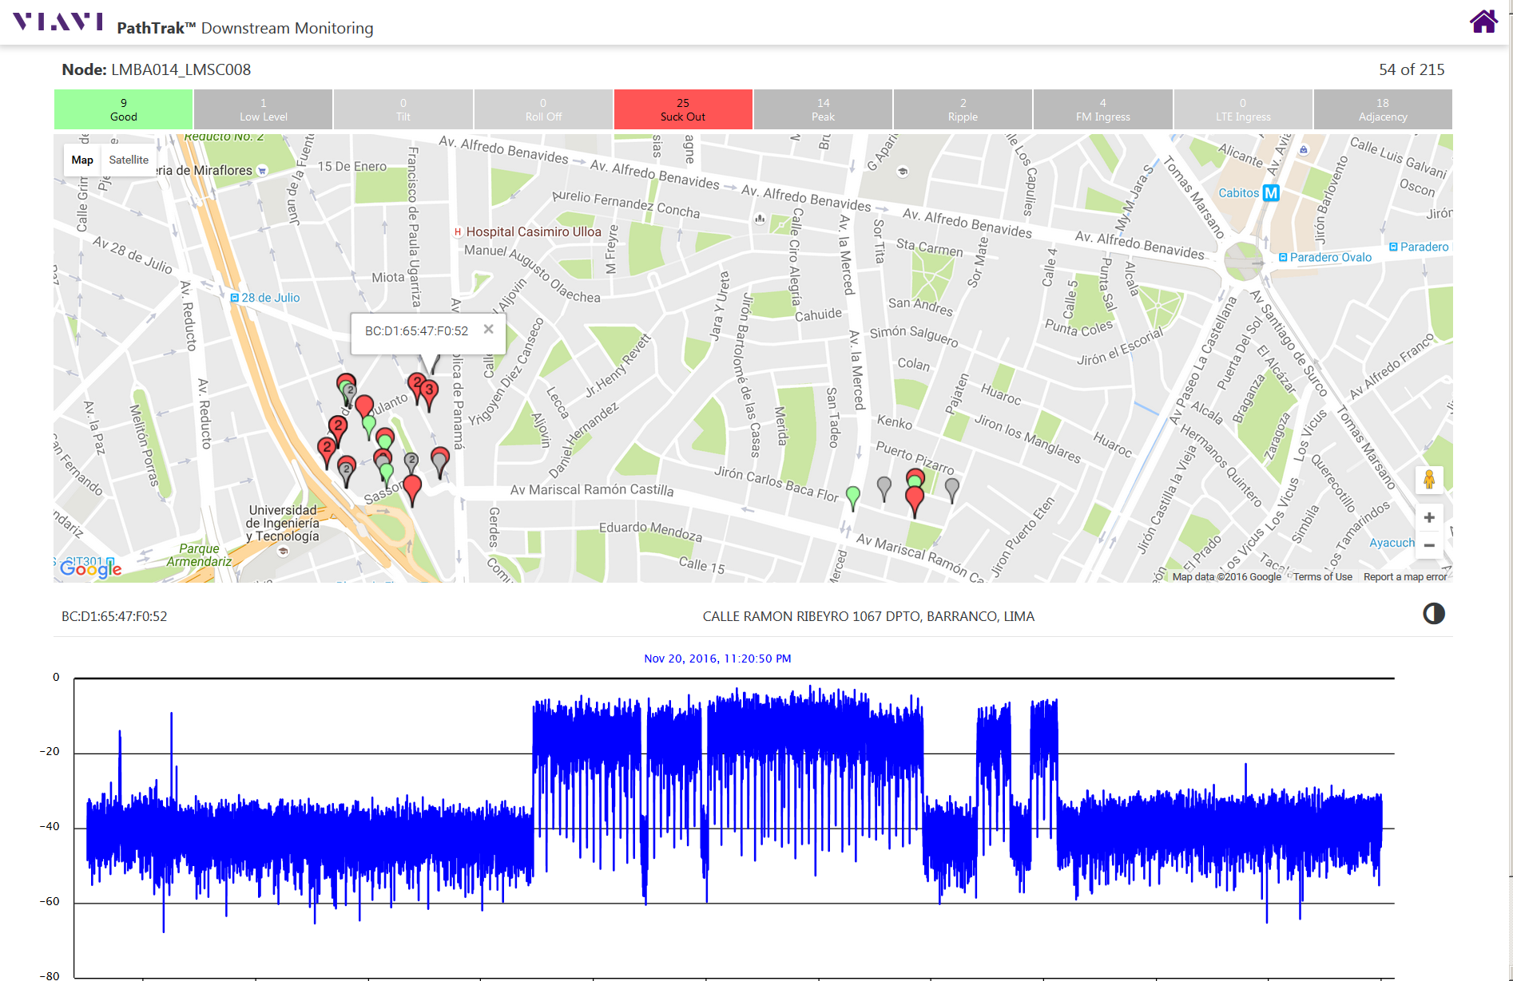
- Clicking the node name in the Node Details list takes you to same place as clicking on Downstream Monitor on the results page of a Technician Search for the node or MAC
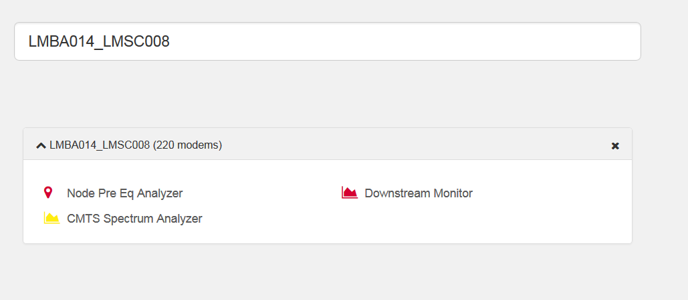
- The far-right hand column on the Node Details page is titled Modems Information and has a clickable “View” in each row
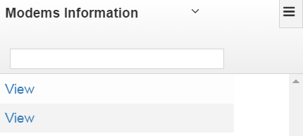
- Clicking the “View” link will show you all the information about every modem on that node
  - MAC address, modem description, vendor, model # hardware rev, software rev, bootr, street address, was it successfully geo-coded, last time data was collected, current status, and trace average count
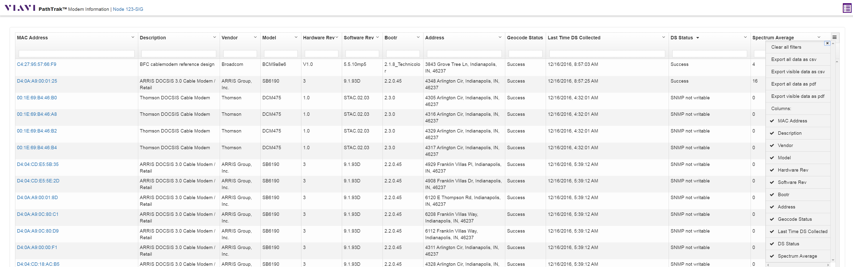
- Again, the report can be exported to .csv or.pdf
- Columns can be switched on or off
- Very helpful to see why modems are not responding
  - Old firmware?
  - Pre-D3?
  - Not enabled?
  - Not SNMP writable
- Used to created exclusion list for modems NOT to be polled

Enhanced Data Content in MACTrak Alarming SNMP Trap

Carrier Performance Index (CPI) score now passed in SNMP trap providing simpler access to carrier health metric

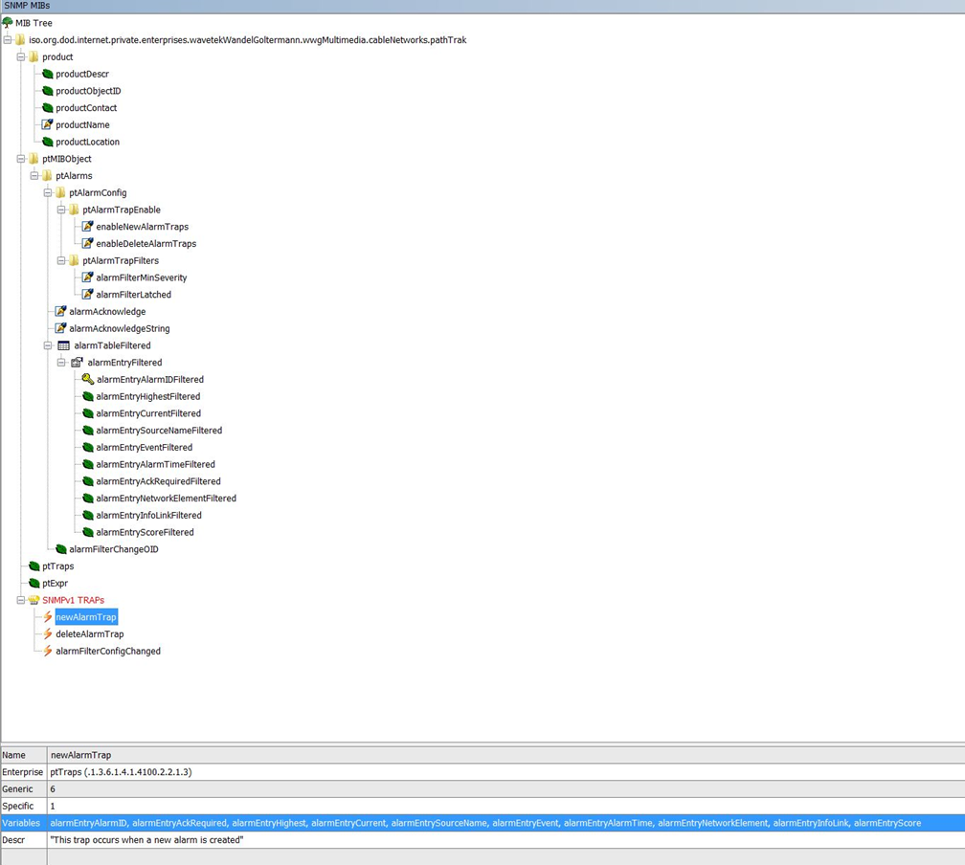

- SNMP MIB Tree from PathTrak V4.4.2 (No CPI scores)

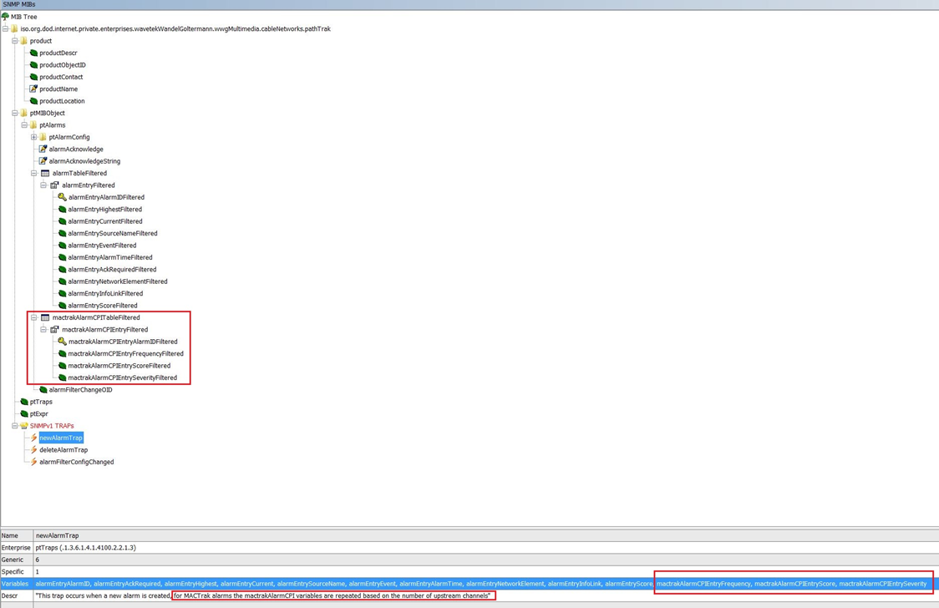

- SNMP MIB tree from PathTrak V4.5 showing new OIDs for CPI scores

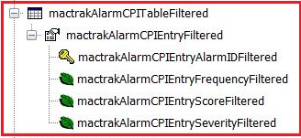

• Details for added OIDs
Also added a modem exclusion list for those modems that should not be polled

- Text file located at \Program Files\Viavi Solutions\PathTrak 4.5\cfg\
- File name modem_spectrum_exclusion_list.txt

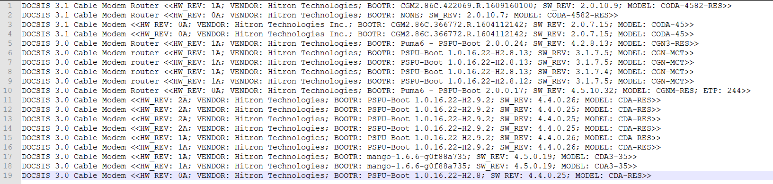

- Sample of the modem exclusion text file
  - System Description returned from standard SNMP “Get”
  - Available in the modems information view

Enterprise Server Support

PathTrak 4.5 includes the addition of higher port count PathTrak Server licenses and associated Software Maintenance and Support plans.

Benefits of larger servers:
- Operational simplification: all nodes can be on a single server in many cases
- Reduced administrative overhead: fewer servers to power, cool, and administer
- Reduced software maintenance and support costs: Per-port cost decreases as server port count increases

Server Sizes (max port count)
- Existing: 160, 1000, 2000, 5000
- New Additions: 7500, 10000, 12500, 15000, 20000

Automated CPE-CM MAC Mapping For MACTrak

Automated lookup of CPE MAC provided by MACTrak to CM MAC for CPE for systems using most CMTS models from Arris, Cisco, and Casa. Eliminates the need for manual conversion, simplifies tracking of issues per-MAC.

Requires Read-only Community String access for CMTS’s, CMTS configuration is done in PNM setup page although no PNM purchase is required to enable this feature.

Direct Access Architecture (DAA) Spectrum Analysis Support

Key Points:
- Nokia Gainspeed and CASA Access Nodes now formally supported in PathTrak
- High-performance, full-featured live spectrum analyzer using Access Node as source
- Plant architecture changes made transparent to user via PathTrak integration
- UI/controls operate identical to RPM/HCU200-based spectrum analyzer
- Choose Access Node from hierarchy just as a traditional fiber node would be selected
- License purchase from Viavi required to activate Access Node spectrum support in PathTrak

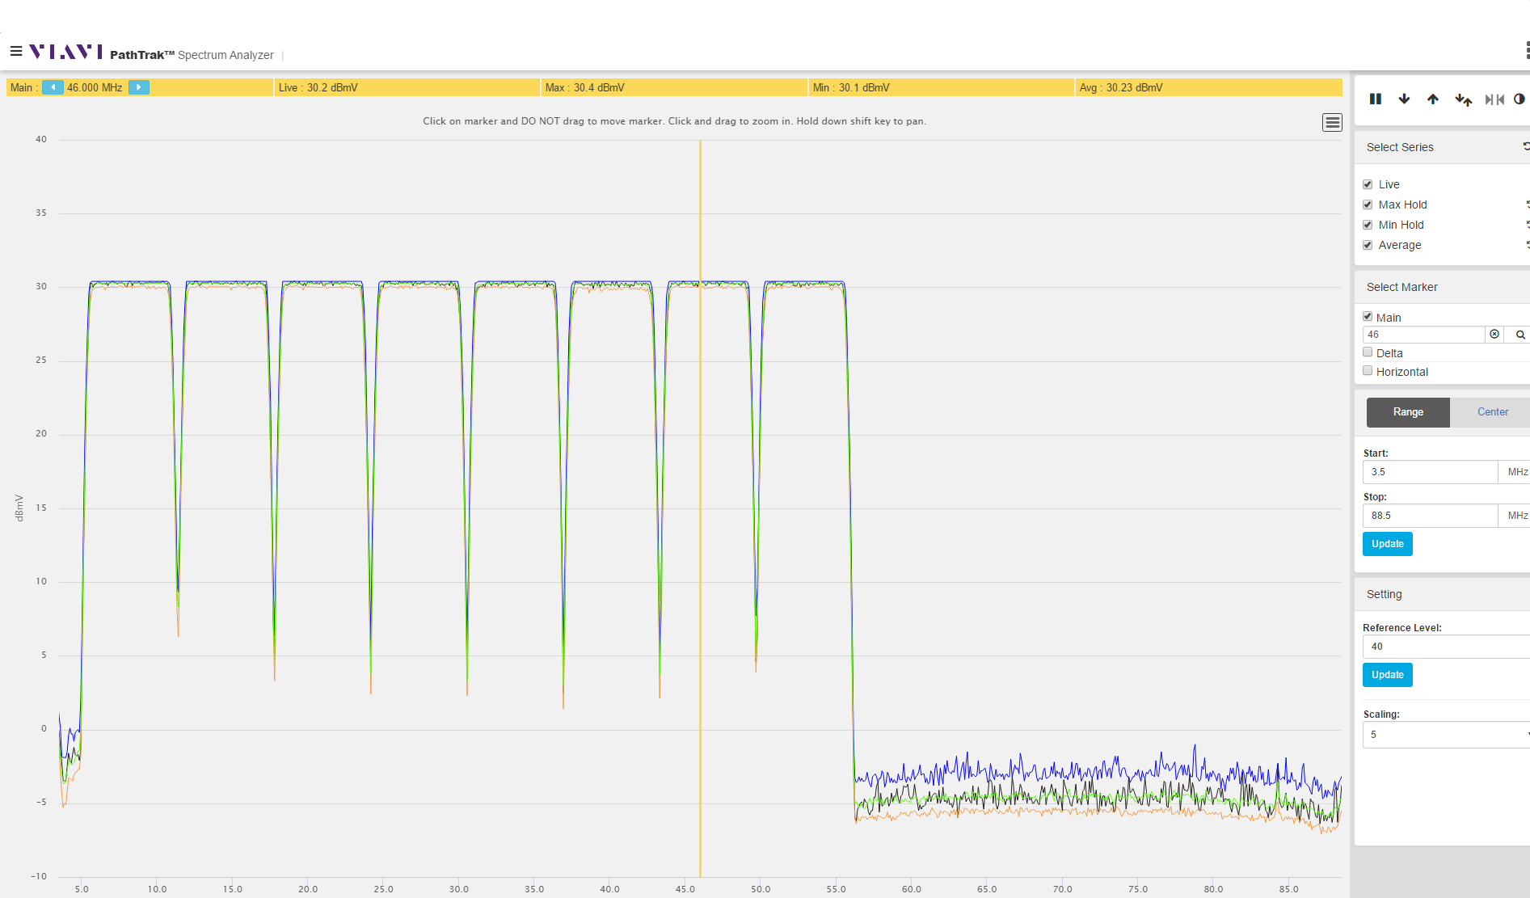

Windows 2016 Server Support

PathTrak now formally supports Windows 2016 operating system

3rd Party Software Updates

Java Runtime Engine and MySQL database have been updated to more recent versions including the latest security and performance enhancements.

- JRE(1.8u112)
- MySQL (5.7.16)

Adjustable MACTrak Alarming Trigger Intervals

Key Points:
- The ability to change the wait/settle time for before the MACTrak Performance Monitoring triggers an alarm or clears an alarm to any number between 1 and 4
Instructions:
Navigate to the screen shown below:
- We can set the triggers in one of two modes
  - Normal (Default)
    - Historical behavior of MACTrak Alarming pre-4.5
  - Strict
    - Strict Mode allows the changes on this page to be used for MACTrak alarm generation and clearing
Normal (Default)
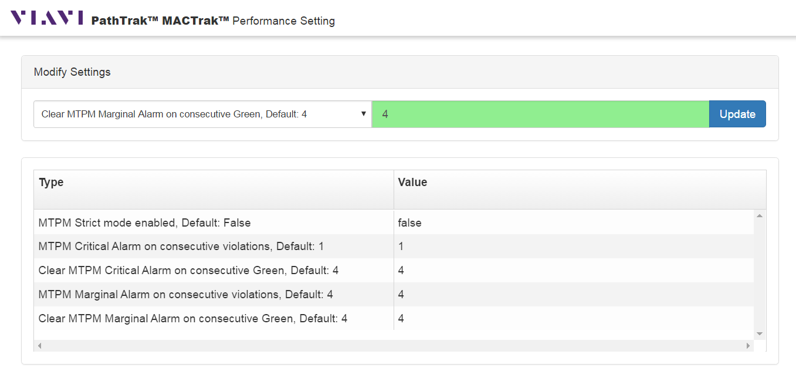
- To enable Strict Mode and change the values
  - Use the pull-down menu and select the parameter
  - Type the desired parameter in the field and hit the Update button
  - MTPM Strict Mode enabled MUST be set to “true”
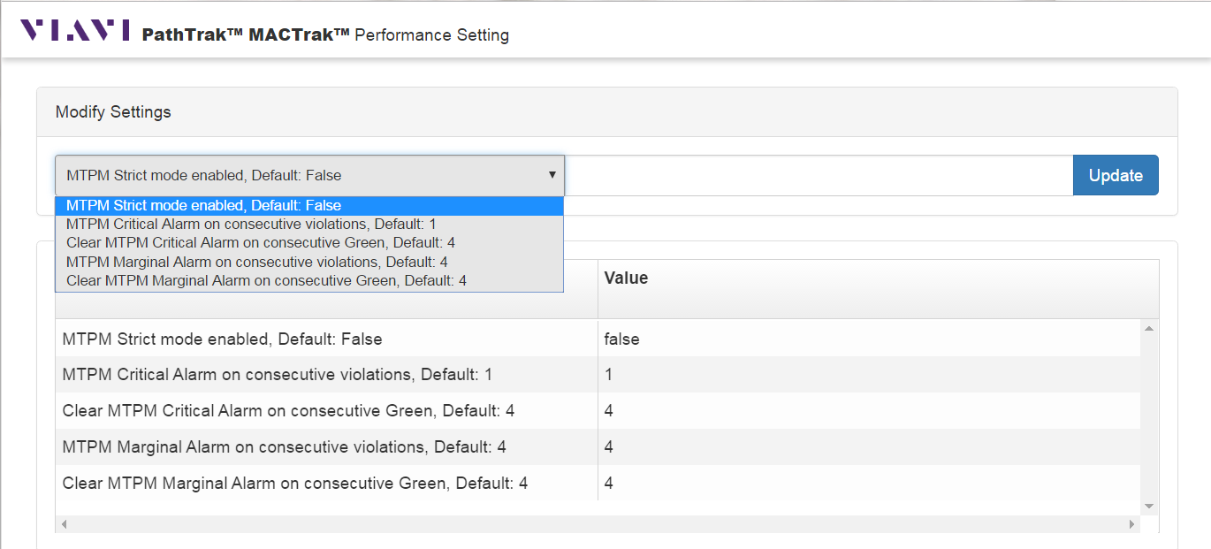
Strict Mode is now enabled
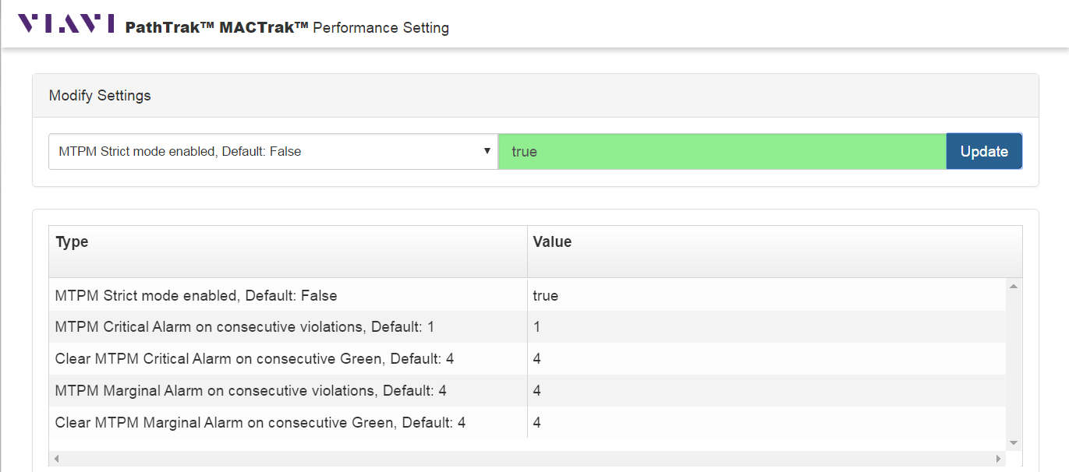
- Repeat the process for the other alarm generating and clearing parameters
- Remember to use the pull-down menu. You cannot click on the parameter and change it.
Strict Mode enabled, strictest alarming and clearing parameters
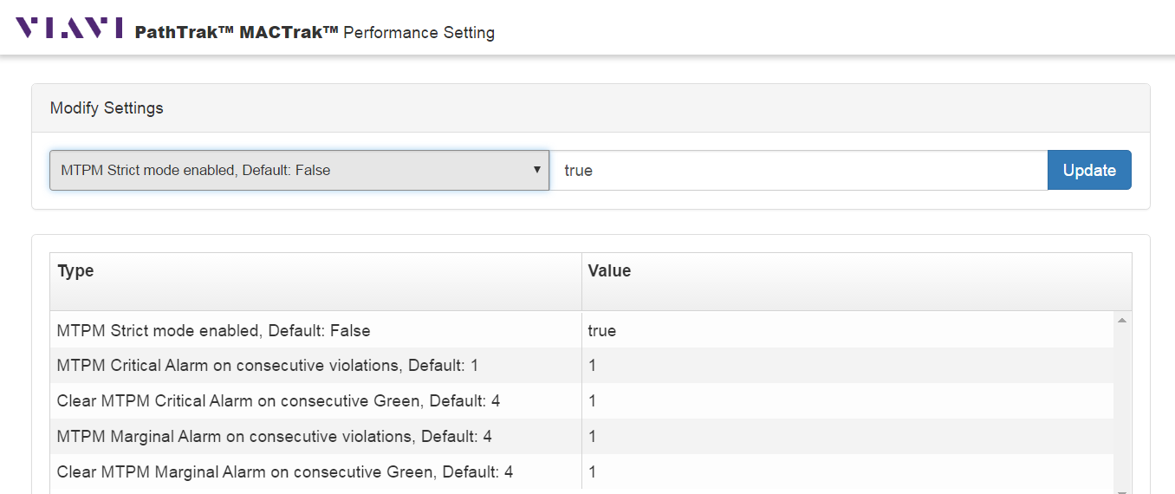

MACTrak Mobile

Key Points:
- The ability to view the QAMTrak and MACTrak analyzer on an Android or iOS based mobile device
- Access the view from the Technician Search results page on a tablet or smartphone
- For now, PCs will still use the FLASH-based QAMTrak/MACTrak analyzer
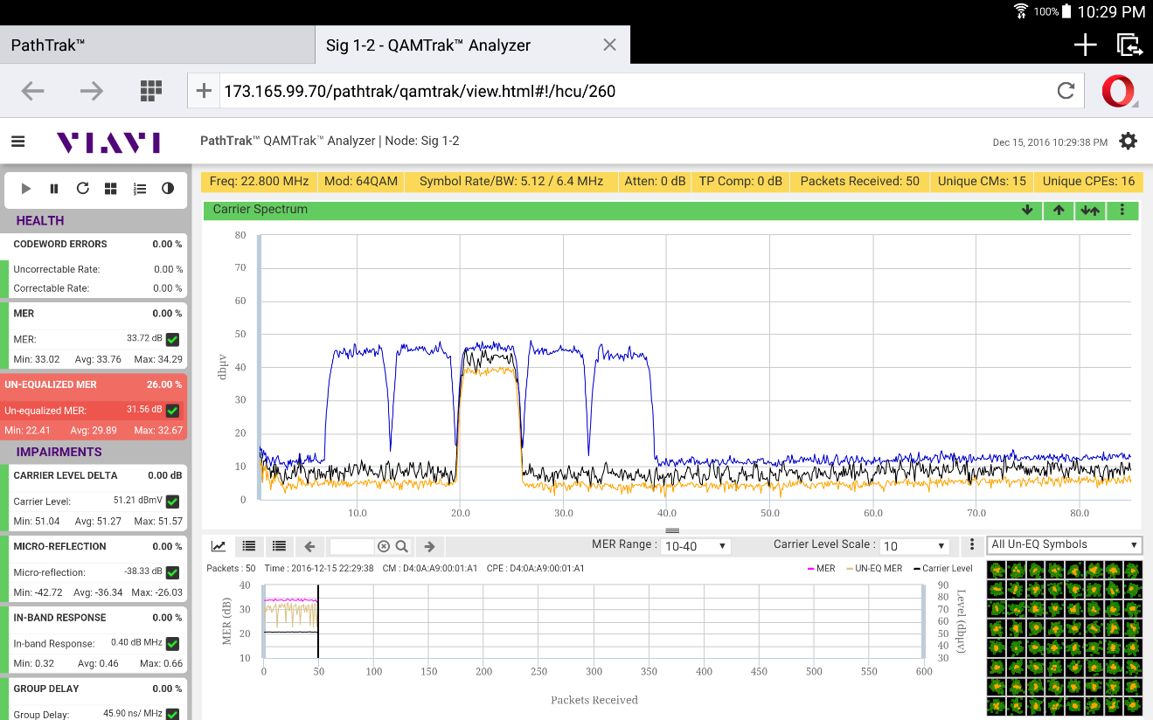
- Light or dark background
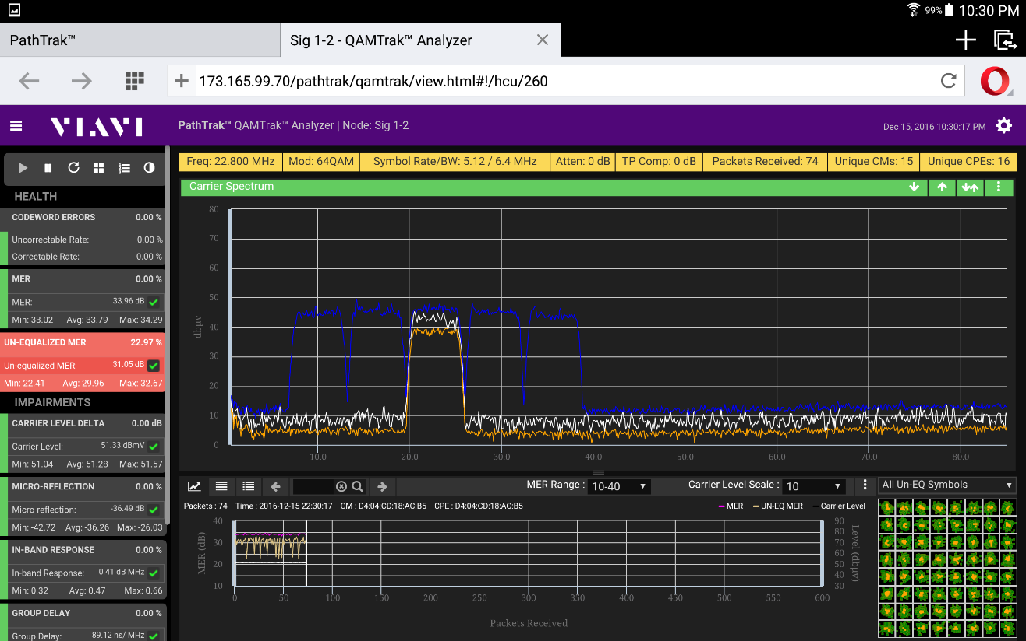

Other Corrections/Enhancements
PTS-122 | - Spectrum Live View shows Loading even after the data has been loaded
PTS-140 | - Remove entries from DB tables that are orphaned after CMTS was previously removed
PTS-142 | - License offline activation - Download Capability Request File throws error
PTS-145 | - List not shown on Node Rank view if non-English language configured
PTS-146 | - Client CPU high when multiple Spectrum Analyzers open on PT 4.4.2

Reference Material/URL’s

PathTrak PNM URL has changed
- From: /pathtrakpnm
- To: /pathtrak/pnm
All major PathTrak functions can be accessed from this link: http://pathtrakserver/pathtrak/help
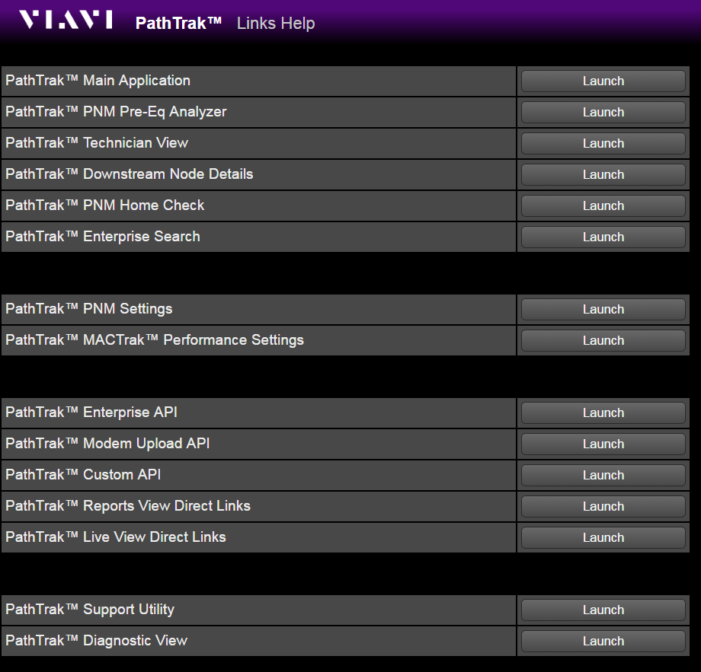

The best method for Tech’s to access all capabilities available for a given node or CPE (MAC) is the Technician View Main Landing Search Page: http://pathtrakserver/pathtrak/tech
or

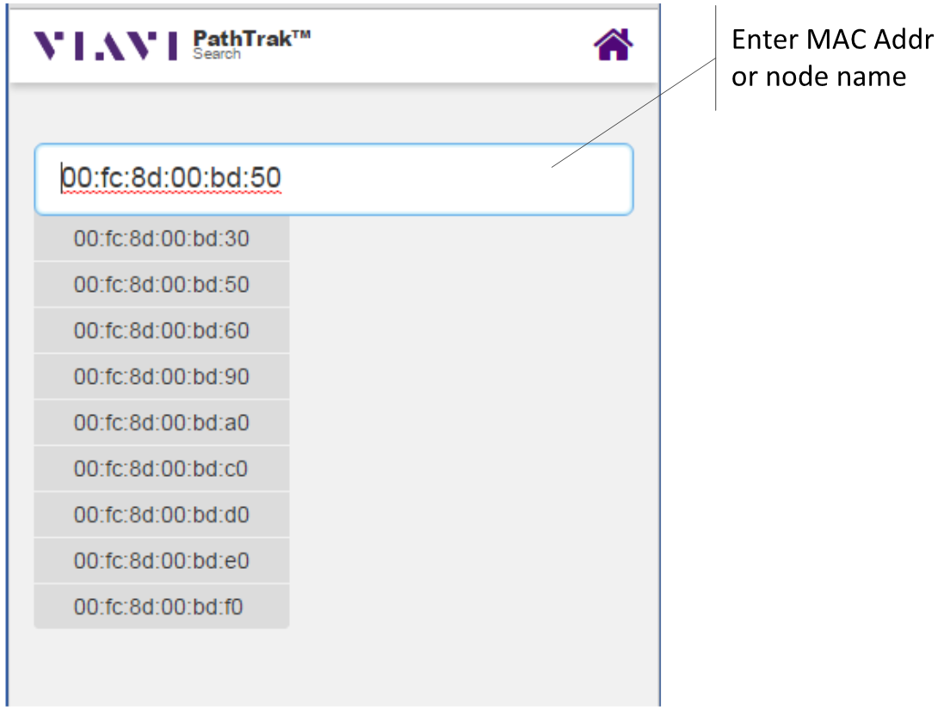

Enter the URL above and search for either a MAC address or a node name. This the quickest, simpilest way to locate a node or a MAC on a mobile device and access PathTrak applications for that node/MAC.

