HST3000 setup to provide an electrical layer 2 loop-back (MAC swap)
*****You must first ensure that the HST3000 has an Ethernet module attached. To do this turn the HST over and look at the module. It should say HST3000 sim – ETHERNET*****
- From the main menu at the bottom select the ETH ELEC tab and Terminate

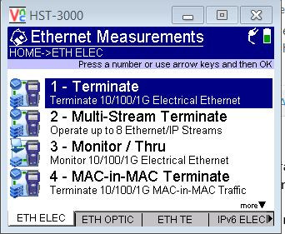

- Allow the test to launch. At the first screen select Layer 2 Traffic

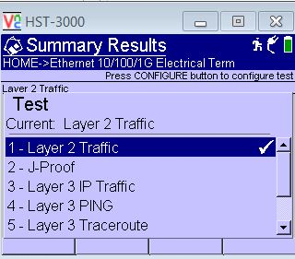

- This will bring you to the Summary Results screen. Press the CONFIGURE button on the left. This brings you into the setup menu. At the bottom left press the SETTINGS softkey and then select LINK INIT. You will see a screen similar to the one below:

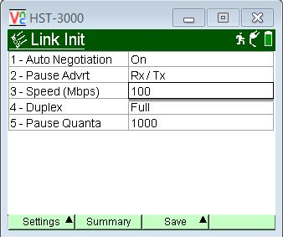

- Check with your tester if the port you are connected to has autoneg turned on or off. (If autoneg is off, proceed to step #5). You will need to confirm the port speed (1000/100/10), and FLOW CONTROL settings. You will also want the Duplex set to FULL. The PAUSE QUANTA can be left at 1000. If you have auto negotiation set to ON, and the port speed set you will first want to verify that the link came up correctly. Press the HOME softkey and down at the bottom left select DISPLAY and then auto-neg stats. If the link came up correctly you will see the screen below. You want to make sure the STATUS is DONE, ACK is YES, Speed is correct (10/100/1000) and the DUPLEX is FULL

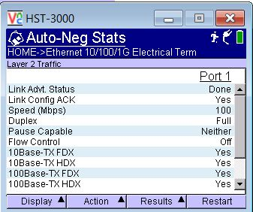

If the link came up incorrectly (you have an autoneg mismatch) then the link will come up similar to the state shown below: Notice Link config ACK is NO and Duplex is HALF.
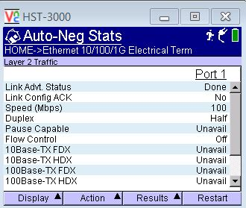
***If the link did come up in half duplex that means that the HST and it’s peer device have a mismatch in their autoneg settings***. Go back to the CONFIGURE menu and set the autoneg to OFF, just make sure your port speed is correct.
- If in the LINK INIT screen you had autoneg set to off and the correct speed set you need to verify the link came up correctly. Press the HOME button. You will be in the summary results screen. At the bottom left press the DISPLAY softkey and select LED. If the link came up correctly, you will see the following screen.
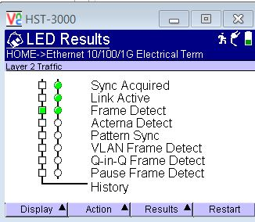

- Now you need to verify we have no filters on. Press the CONFIGURE soft key and at the bottom left select SETTINGS, and then scroll down to FILTERS, arrow to the right and select ETHERNET and you will see the following screen.

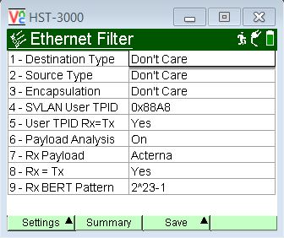
- Just ensure that Destination, Source and Encapsulation all say DON’T CARE.

- Before going to the RESULTS screen you will need to give the tester your SOURCE MAC address. To do this press DISPLAY, and select ETHERNET. You will see the screen below. The SOURCE TYPE is the units MAC address

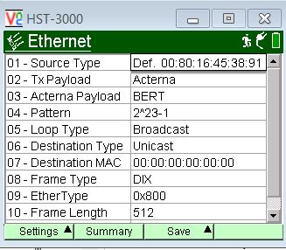

- Now that we have the link up correctly we can put the unit into Line Loopback (LLB) mode. Press the ACTION softkey, the scroll down to LOOP then scroll over to LLB. Press OK
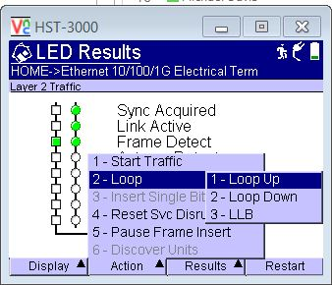
- You are now ready to receive traffic from your tester. The unit will take all frames that come into the RX port and echo them back out it’s TX port while doing a MAC swap.

