Revoking Multiple Licenses from a Lost/Damaged/Stolen Device

This section describes how to revoke multiple licenses from a lost/damaged/stolen device using the StrataSync server. First, you must revoke the floater licenses assigned to the device, and second, delete the lost/damaged/stolen device (asset).
1 Log in to the StrataSync server.

2 On the Home main page double-click on the StrataSync Enabled number under Asset Class.

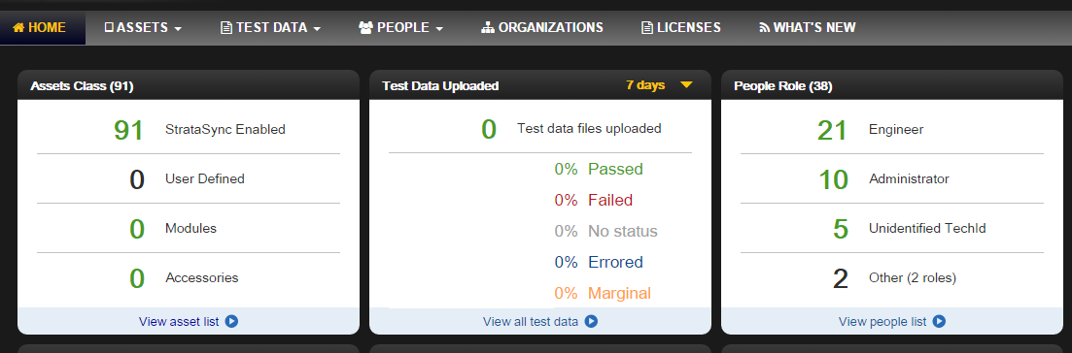

3 Double-click on the row containing the device.

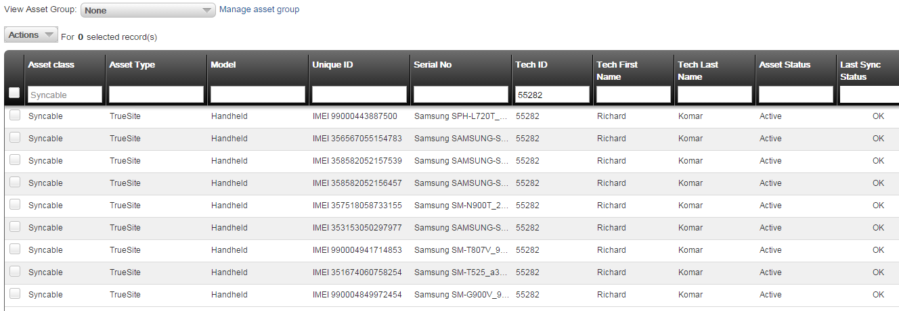

4 You will see the following screen as an example.

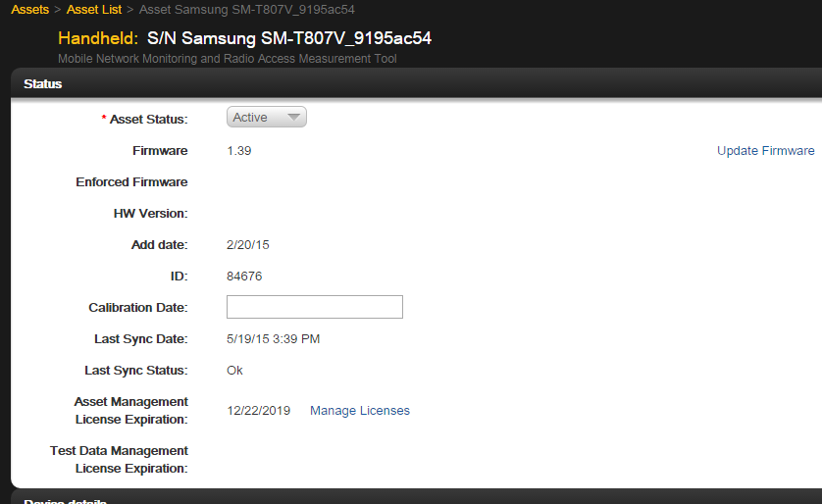

5 Scroll down to the Floating Software Options.

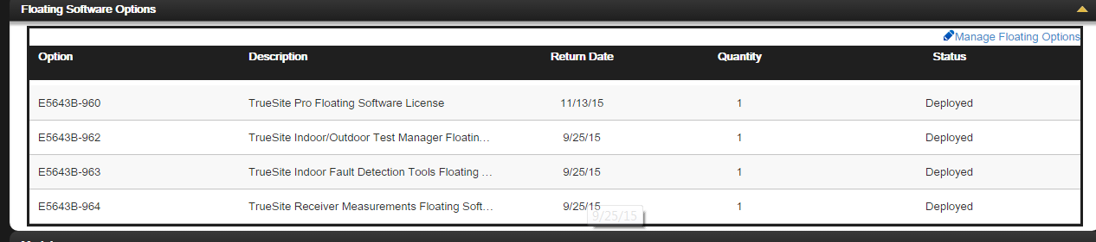

5 Select Manage Floating Options. You will see the following screen.

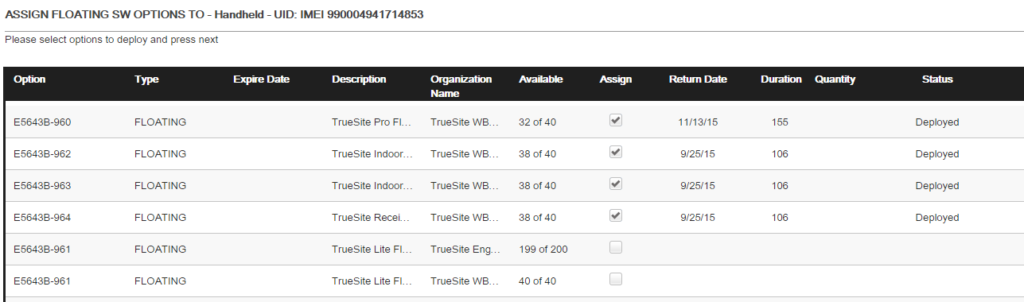
6 Uncheck the deployed floating licenses.

7 Click Next and then click Deploy.

8 To activate the license revocation, go to the RANAdvisor TrueSite app on the device,
select StrataSync, and click SYNC NOW.

9 Go back to the Asset list, check the lost/damaged/stolen device, right click on the row and select Delete to remove the device from your inventory.

