Occasionally when a P5000i is used with Windows 10 it is not recognized by the computer. The below procedure shows how to revert the probe’s driver so that it will be recognized and be able to be used by FC Pro.
The initial symptom is you plug in your P5000i to your PC and launch FC Pro. The screen shows no microscope or tip and you usually have a message “plug in a device to get started”.
First navigate to device manager. For WIN10 just click down the bottom left on the Microsoft icon and just type in device manager. Select PORTS (COM+LPT). You will see something like the below screenshot:
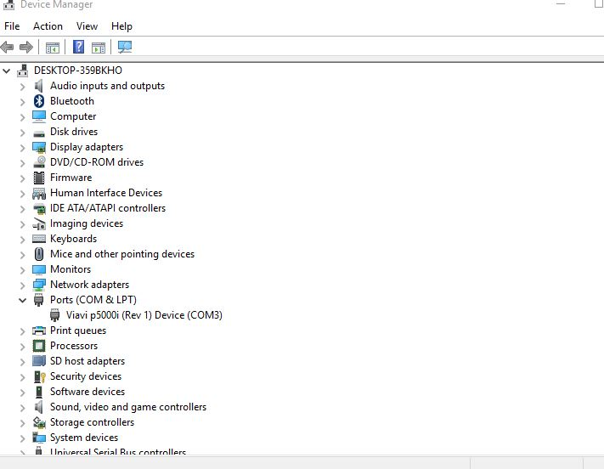
Right click on the Viavi p5000i (Rev 1) device (the COM port will vary) and select properties. You should see something similar to the screen below. Some WIN10 PC’s will have the Roll Back driver as a selectable option, while others might show “Delete driver”.
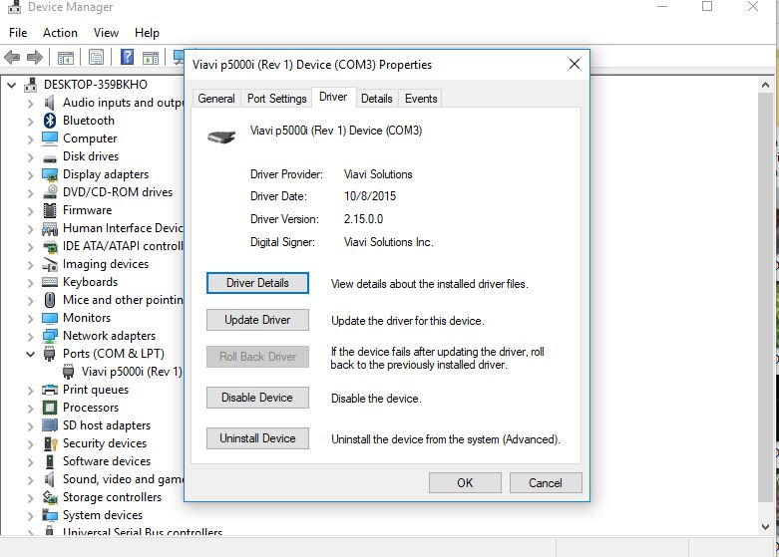
- Select Update Driver.
- Choose “Browse my computer for driver software”
- Choose “Let me pick from a list of device drivers on my computer”
- You should now see the screen below

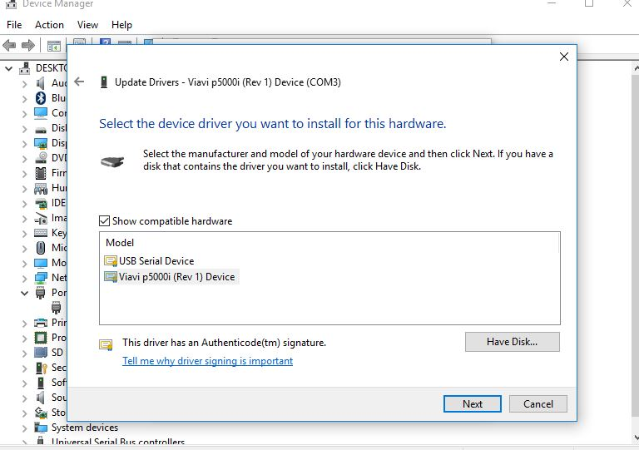
- Click on USB Serial device
- Click on Next
Windows will now revert the driver. Close device manager and launch FC Pro. If the probe is not initially recognized, unplug it and plug it back in. Fc Pro should now see the probe.

