Configuration Requirements

Create user accounts for all the techs

Step by Step Usage Procedure

https://insertHostnameHere/pathtrak/techui/app/views.html

The user will need to login
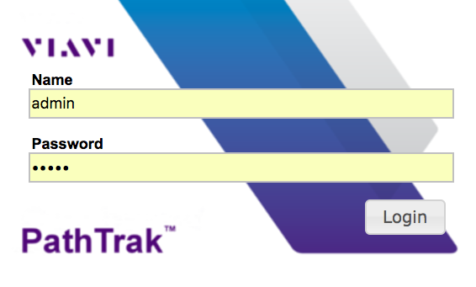

When logged you will see this node/port search page

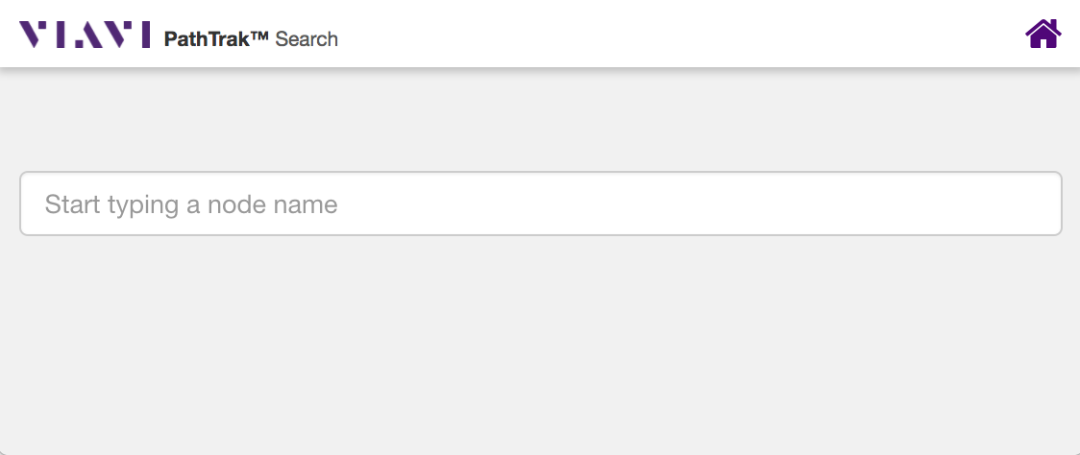

Start Typing a port or node name in the text box. The system will dynamically find port or node that matches what has been typed. See Image below.

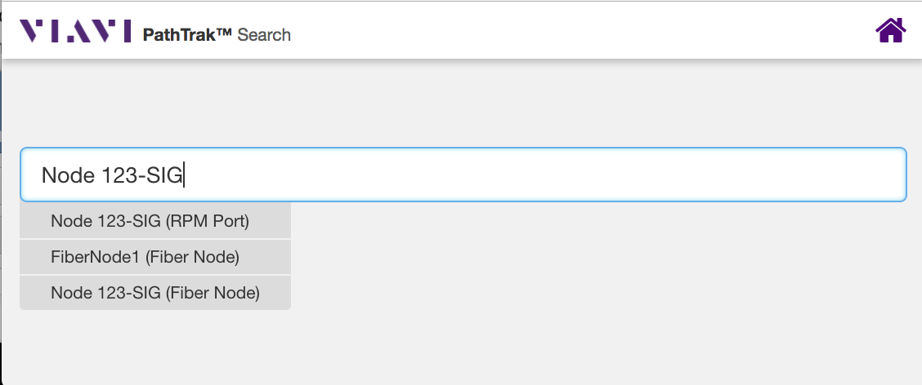

When the port you want to view is visible, select it from the drop list. The app will display a list of applications that can be launched to analyze the selected port.

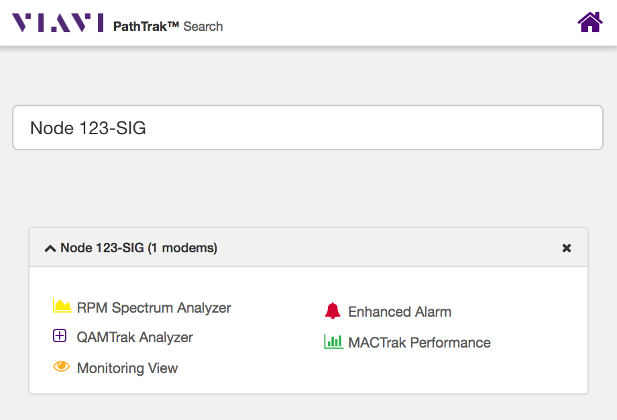

After selecting, a port, the system will show the user a list of tools.

Click on to launch the spectrum analyzer (Use this for FieldView)

The Spectrum Analyzer
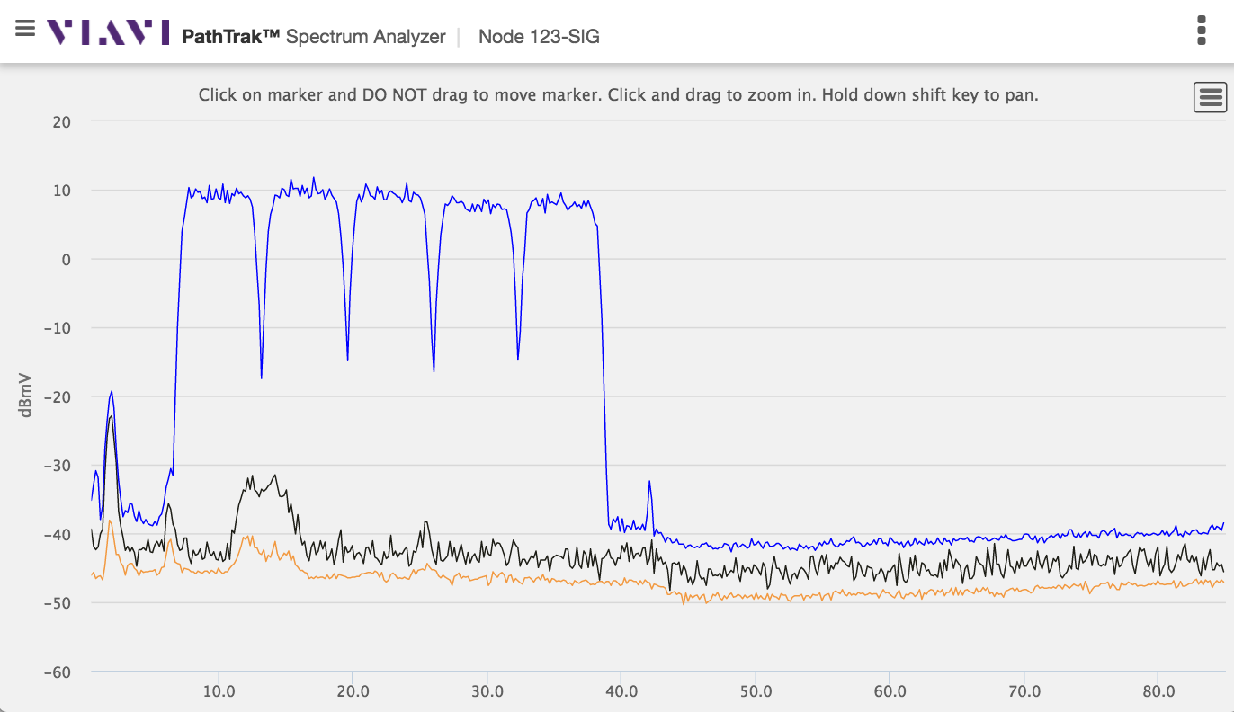

Click on the in the upper left title bar to slide in or out the list of tools or to jump back to the port search

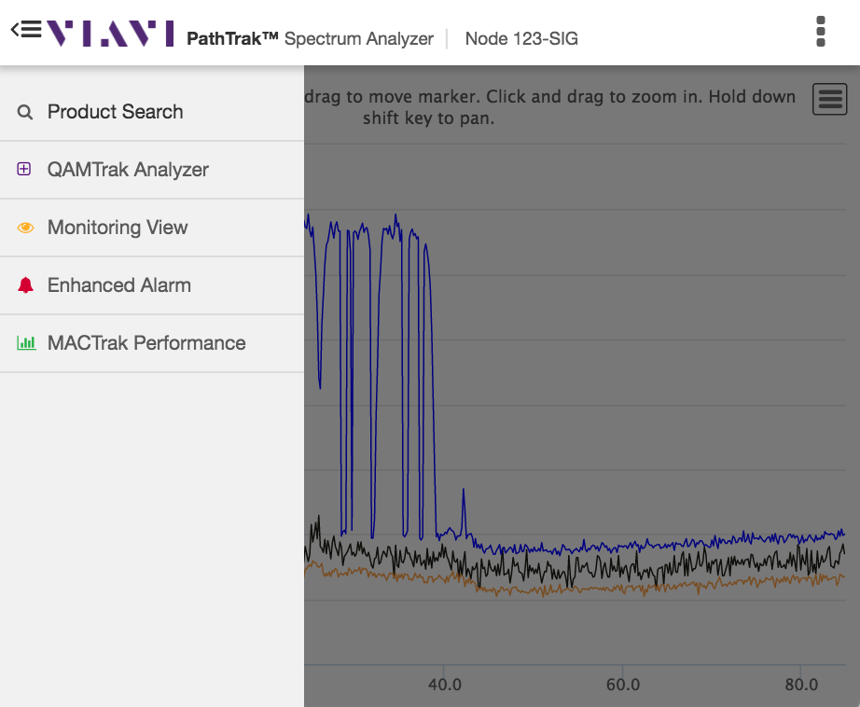

Click on the on the upper right title bar to slide in or out the Spectrum Analyzer configuration controls.

Note you may have to scroll up or down to see all the spectrum analyzer controls