Creating a dialup connection on Windows 7 (Required to do a VoLTE call setup when phone is in mode):
To define a dial-up networking connection, you will first need to ensure that a modem driver has been configured for your modem in Windows.
- Open the Start menu and select Control Panel.
- Select Network and Sharing Centre.
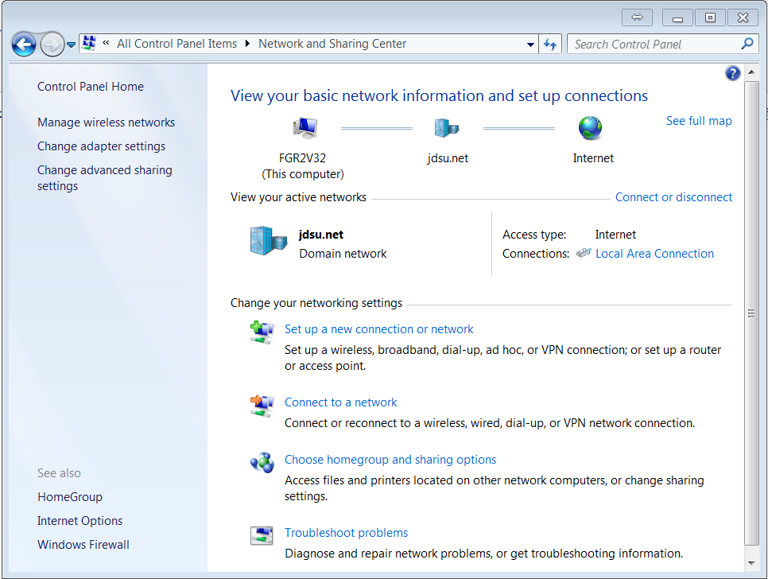
- Once you are in the Network and Sharing Center, click on the Set up a new connection or network option

- Select Set up a dialup connection.

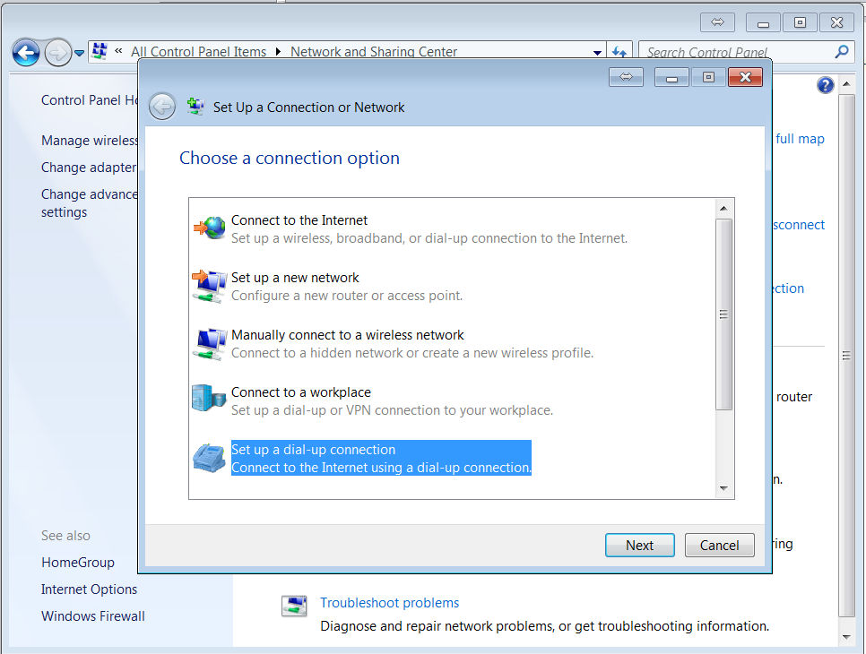

- Select the appropriate Modem for the connection (optional step)- Applicable only when you have or more modem connected).
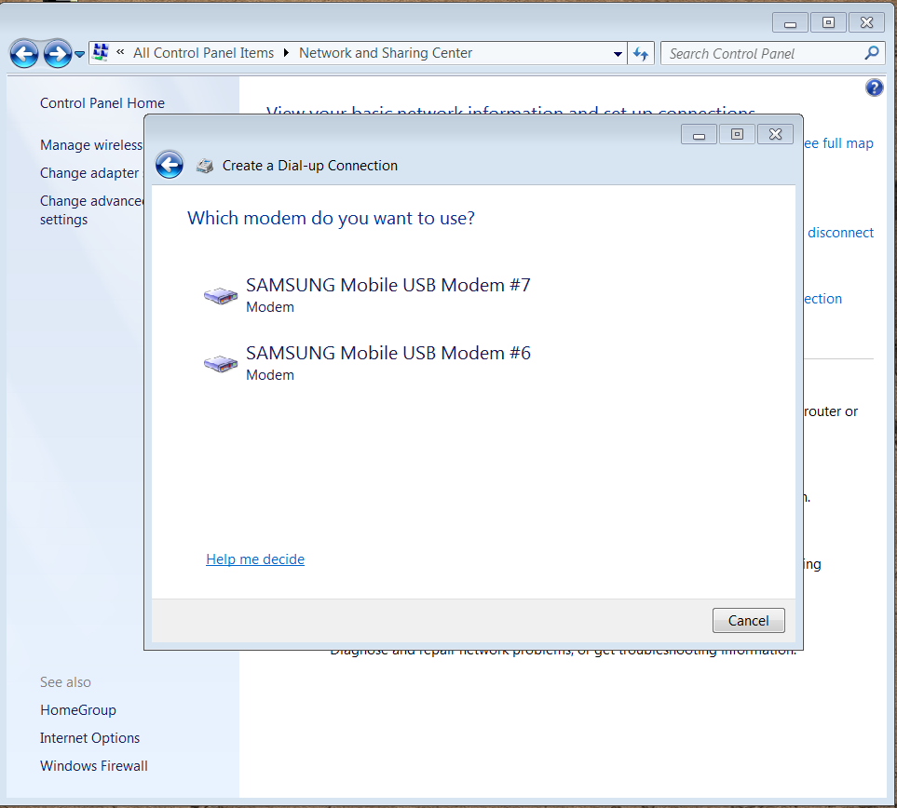

- Enter the following:
*99# (for phones using 3GPP standards) or #777 (for 3GPP2 standards) in the Dial-up phone number field
Your Connection name (you can type any name you want here).
Your user name and password (provided by your carrier), then click Connect.

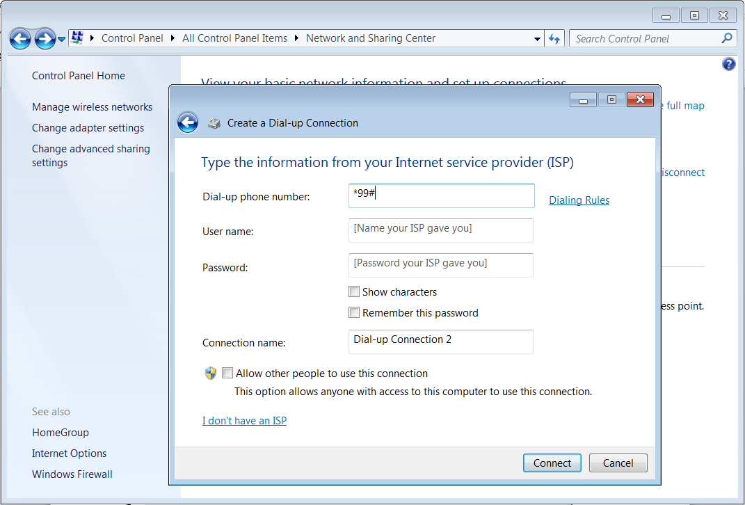
Note: In some cases, a user name and password are not required.

- The Wizard will attempt to connect to the dialup internet and your dial-up connection is ready.

Using the same Dial-Up connection:
- The next time you connect the same phone to the same port in the same project, select connect to a network.

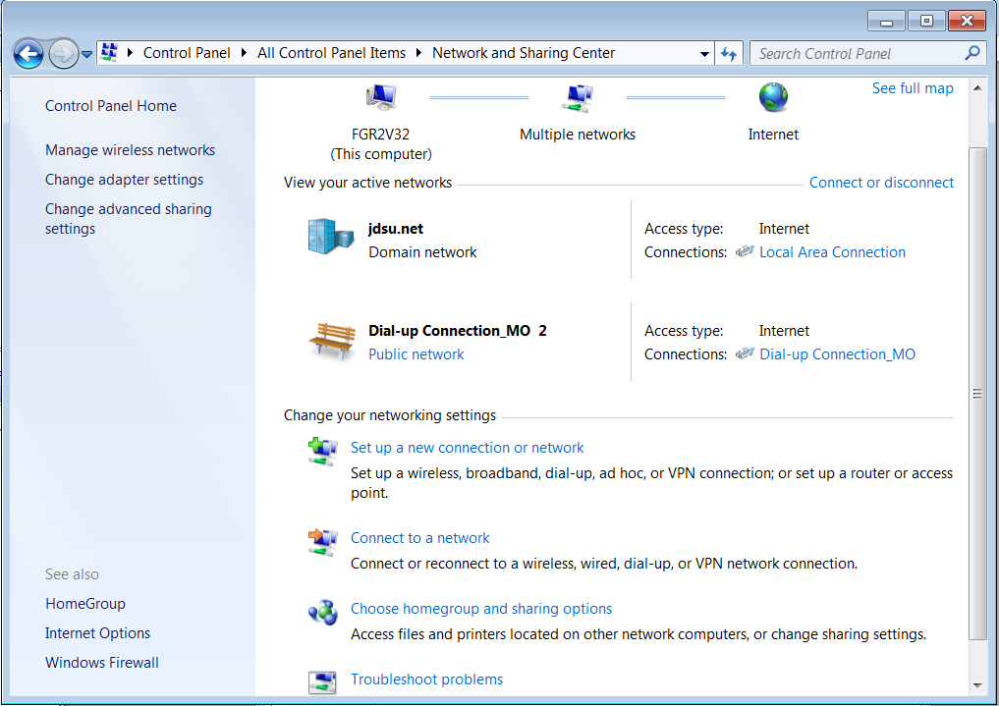

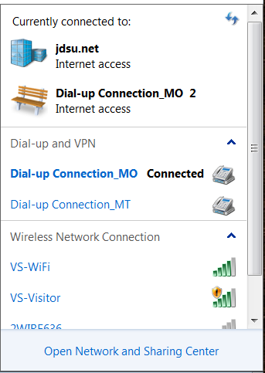
- This pop on window will pop up:

- Select the dial up network associated with the phone, and select connect.
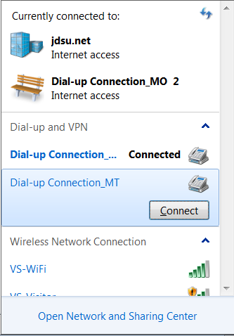
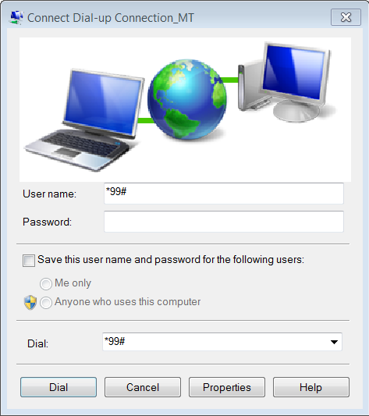
- The follow window pops up. Enter the user name and select “Dial”.

