Enabling TLS 1.2
See:- https://docs.microsoft.com/en-us/windows-server/identity/ad-fs/operations/manage-ssl-protocols-in-ad-fs
TLS Client and Server enabled. Note that both parameters for both the Client and Server need to be configured as per the url above.
HKEY_LOCAL_MACHINE\SYSTEM\CurrentControlSet\Control\SecurityProviders\SCHANNEL\Protocols\ ….
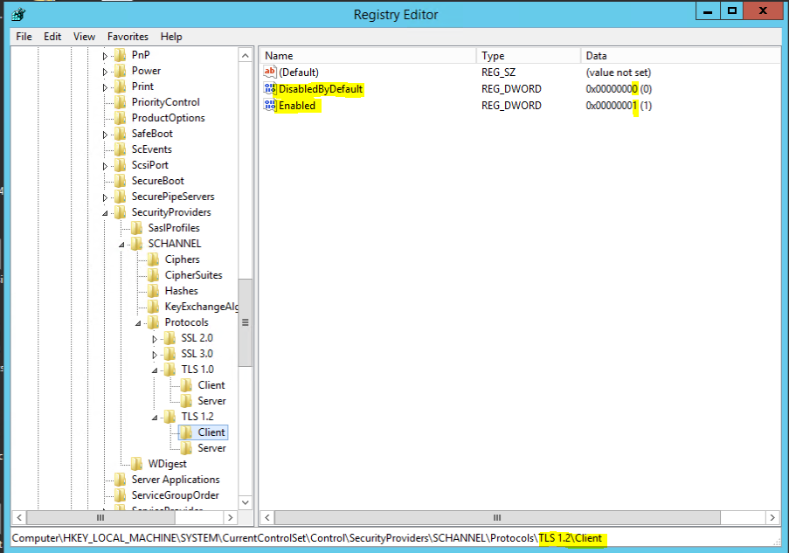
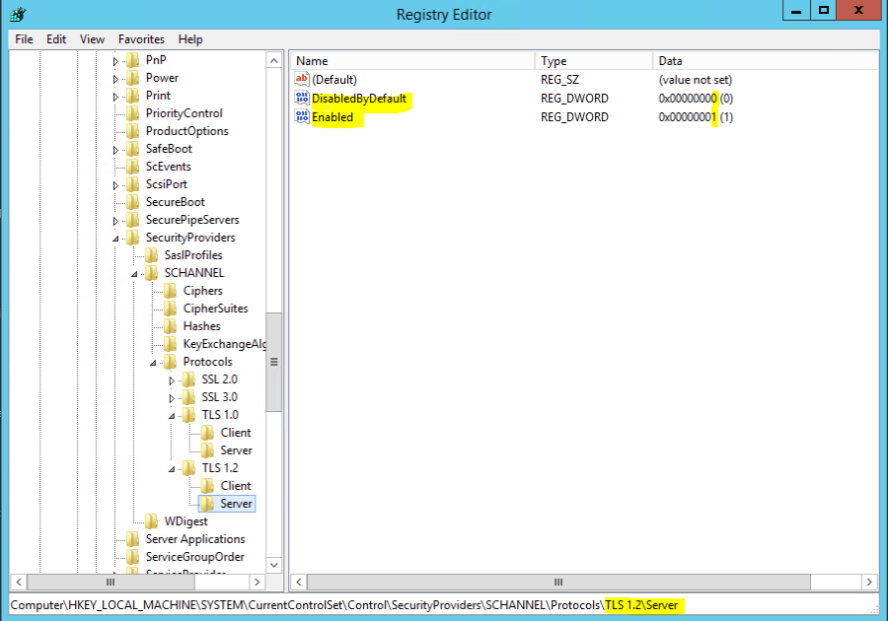

And for comparison and example of TLS 1.0 which was disabled …
