DOCSIS Check – Troubleshooting

In general, when performing DOCSIS Check the meter displays:

- No CPE IP received

- Receives an IP address but still failing to perform throughput test

- Unable to RF Sync to StrataSync

Troubleshooting procedures:

1- Power cycle the meter

2- With only RF cable in port 1 go to CATV -> Connection -> start it

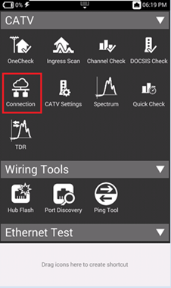

3- This application performs the protocol between CMTS and ONX meter in order to obtain an IP address

4- Outcomes:

A- No CPE/ IP received it means that the meter has to be provisioned to the CMTS, using CM MAC 1, CM MAC2, etc.

Even if you think the meter is provisioned most of the time you have to delete and provision again.

In DOCSIS Check you have sometimes 30% , 68%, 98% (it varies). With no IP address the meter is not able to perform throughput test or RF sync to StrataSync.

The exception is when you have the meter provisioned in 2 or more areas you could try to Start Connection -> press Stop -> DOCSIS Service Plan -> choose other CM MAC and Start it again, if this was issue the meter will succeed in getting an a valid IP address.

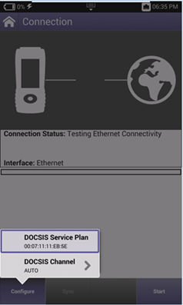

B-  The IP address is displayed, then we press the Home button and go to System -> Web Browser -> try to reach [www.google.com](https://urldefense.proofpoint.com/v2/url?u=http-3A__www.google.com&d=DwMGaQ&c=ZPV2KfcoPshFOQyzifv8OQ&r=McHYjra13xq3uaQhTCN9tpX9BpijYHfFy4AMLYApmfU&m=Ed10WyORkZxyPAupVveX1noHV-SwSENlb9KbAZor8gs&s=mJiOw0CgZ1lfFjycJ4wy4aRH8rpTlvcimRPDBcA7S0Q&e=)

     Sometimes the IP released is internal to the company and it sends the user to the company page to provision the meter.

So, if it cannot reach google therefore it is a provisioning issue.

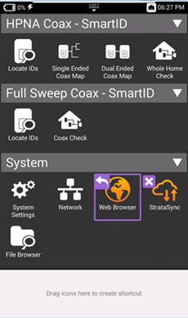

C – Another task to be attempted:

If the meters are displaying No CPE IP received or if it is failing in performing DOCSIS Check, this is a provisioning issue.

* Perform a DOCSIS Check in a meter that is working, then go to Registration
* See the Config File and try to provision a similar Config File to the meter that is not working

