Reports

Reports module helps us to schedule report performance of a Network component this is basically scheduling the trends data of a NE and getting as a scheduled email .

The feature of getting trends data is done by the underlying product functionality by using and email server this email server is responsible for sending out the scheduled email to the specified email ID

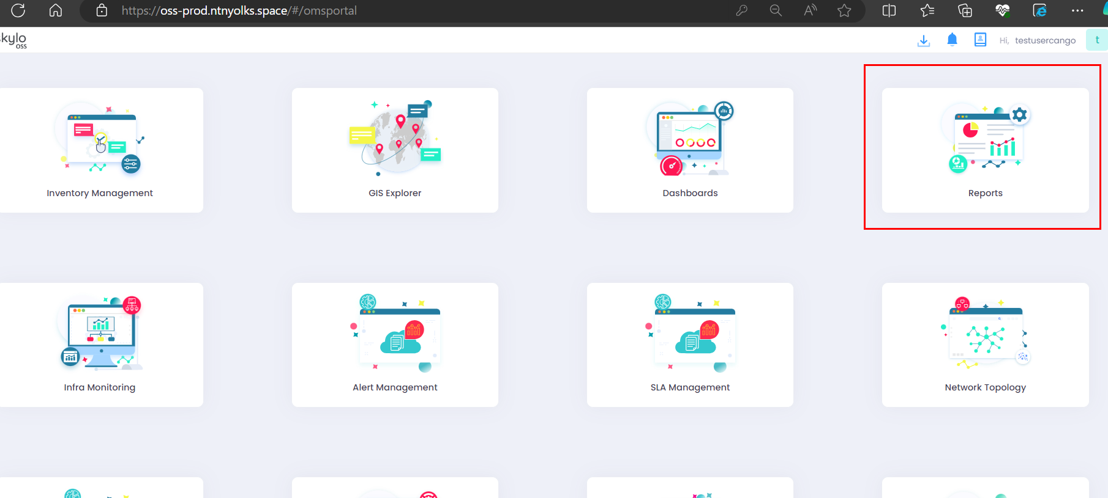

This model mainly exist because customer cant able to get into the UI everyday and look at the trends data or how the network component is performing .

For tackling this everyday checking we can simply schedule the KPI performance as a report And get it via email

Click on report type drop down find click on infra data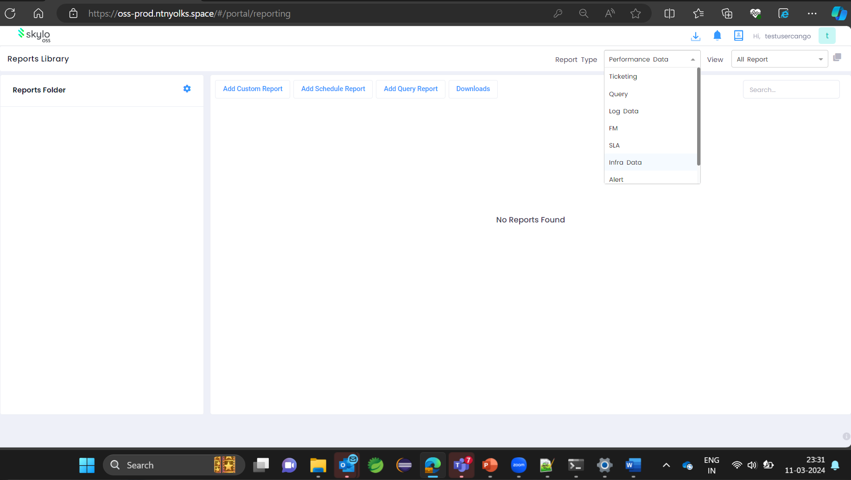

Click on gear icon in this side menu which is the manage folder button where we can create a new folder .

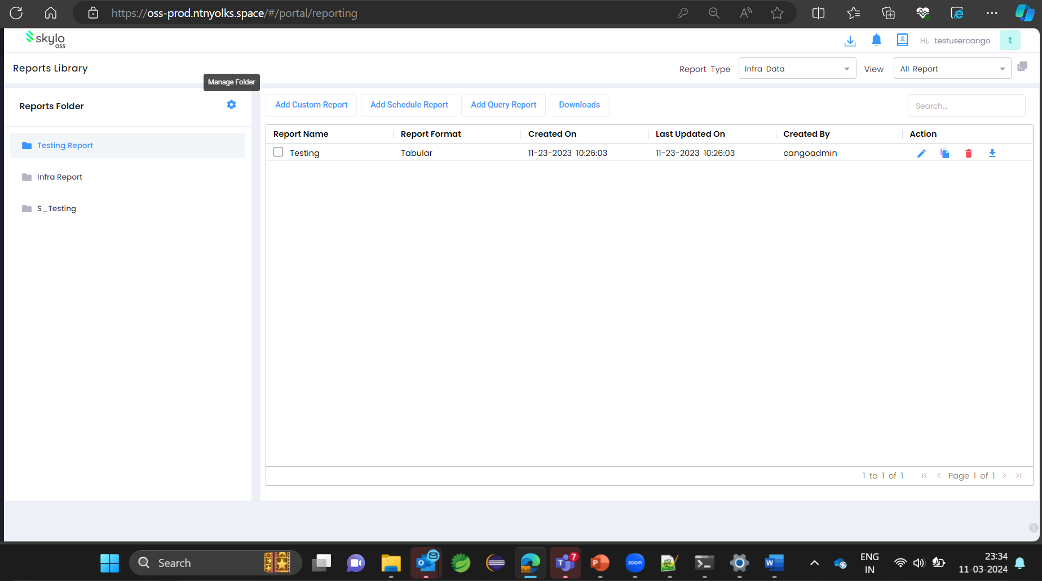

It takes us to a new page where we can see the folders which are already created and we can also create a new folder

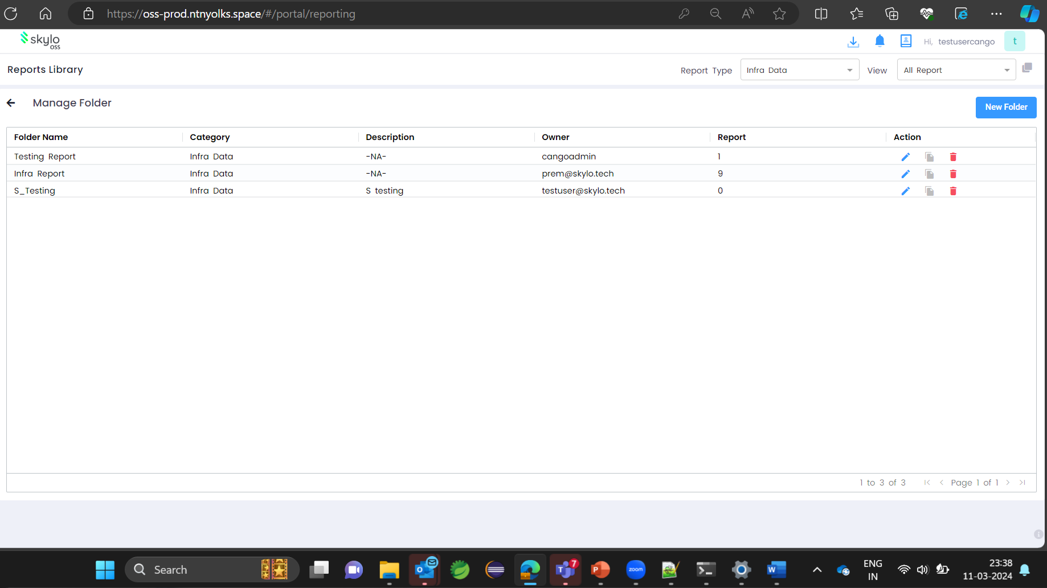

Click on new folder and give the required name for the folder and click on infra data in the drop down and click add .

The newly created folder is displaying

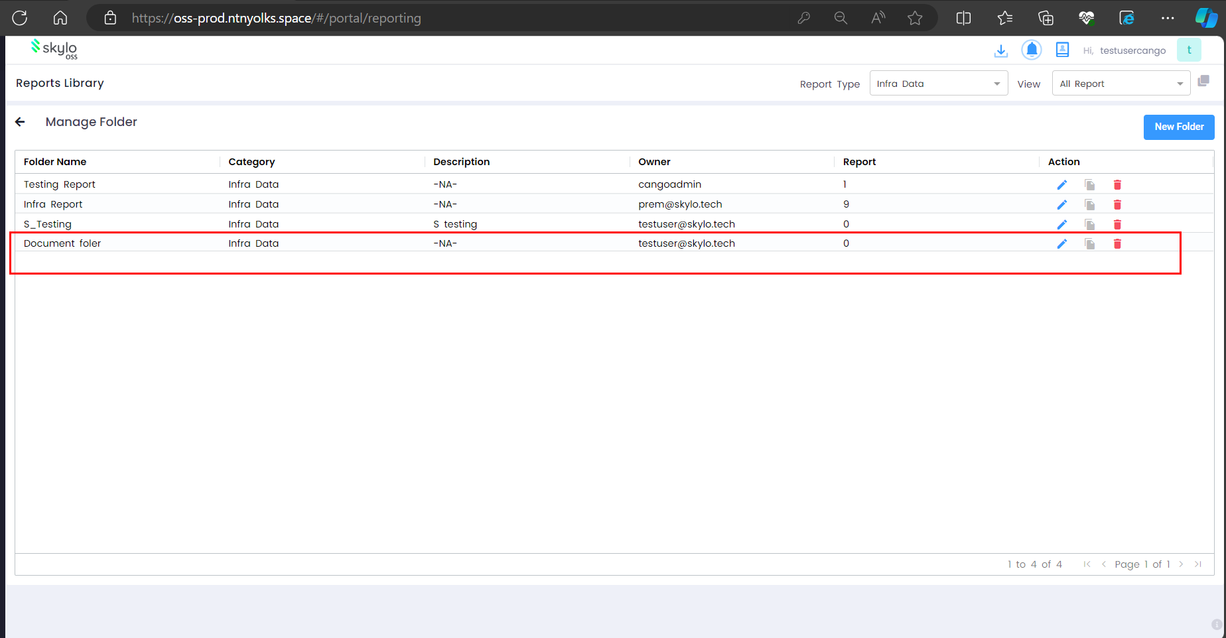

When we go back the created folder is also displaying in the side menu

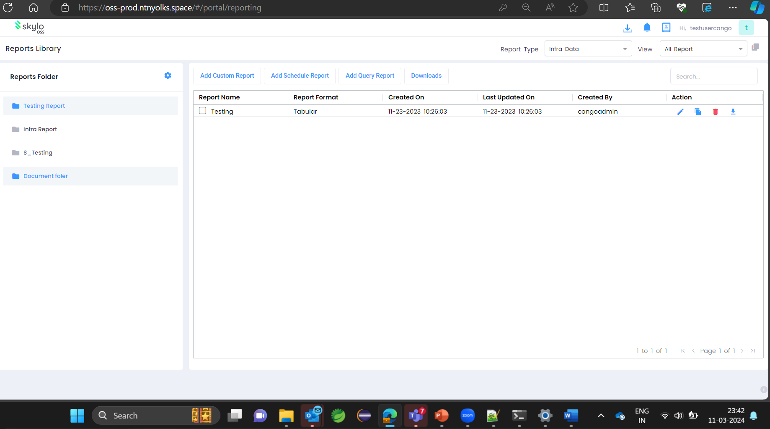

Click on add schedule report below page will be displayed .

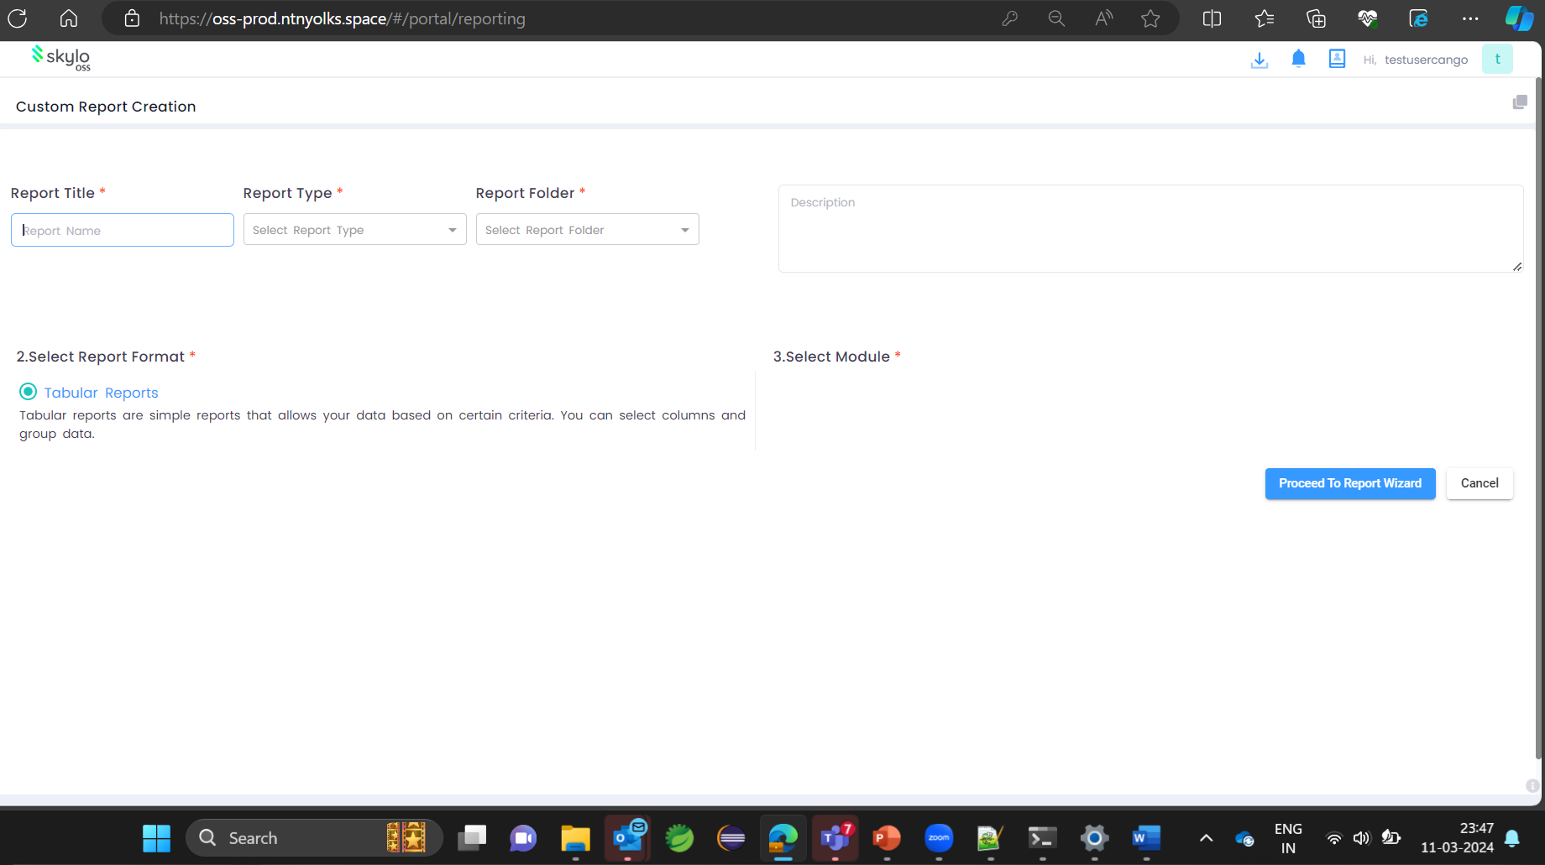

Here give report a name and select infra data in the report type drop down and select the created folder in report folder drop down and clik KPI radio buttonand click on proceed .

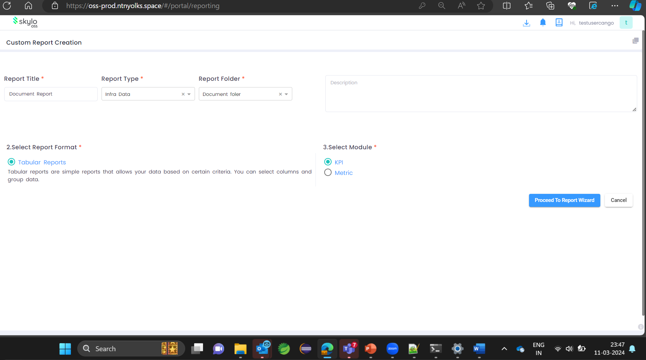

In the next page it shows 2 components one is we have to select the exporter or the job second is we have to select the kpi from the job and click on next

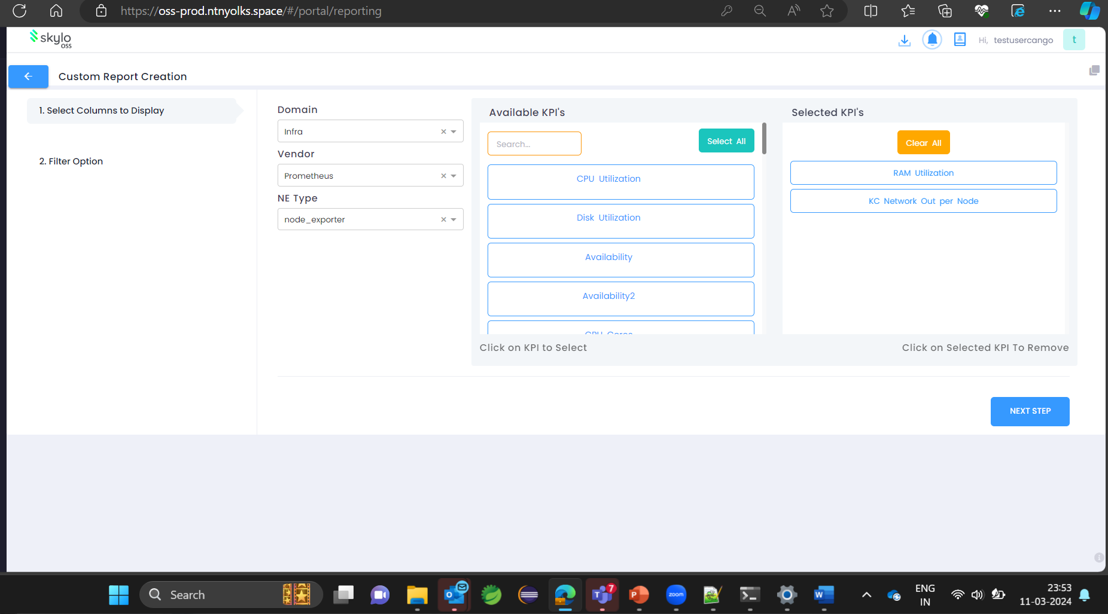

Now click on granularity and clik execute report

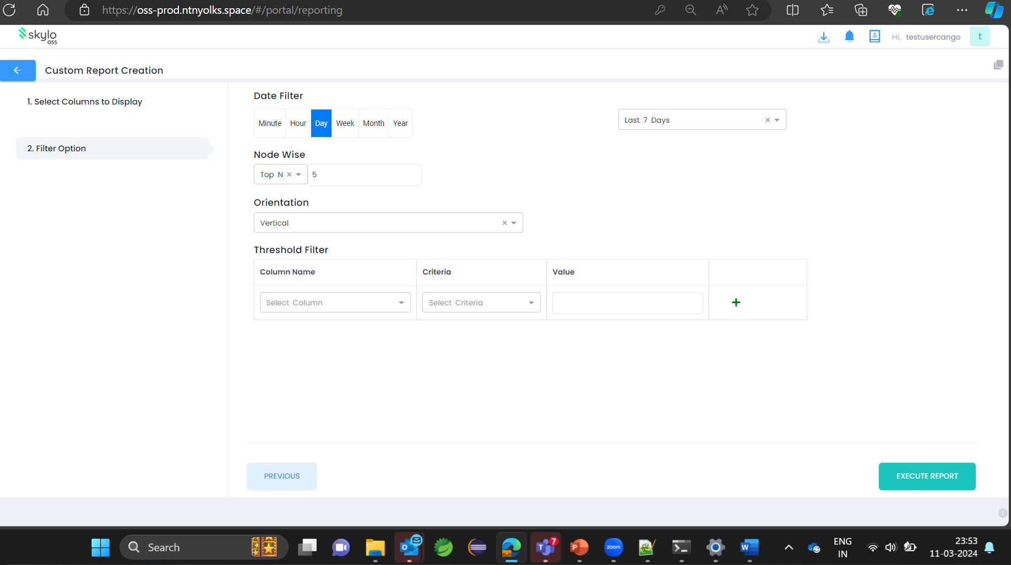

After we execute the report we can able to see the date of points and the graph for the saved kpi we can able to the chart customize further by changing the style I am changing the granularity

And click save .

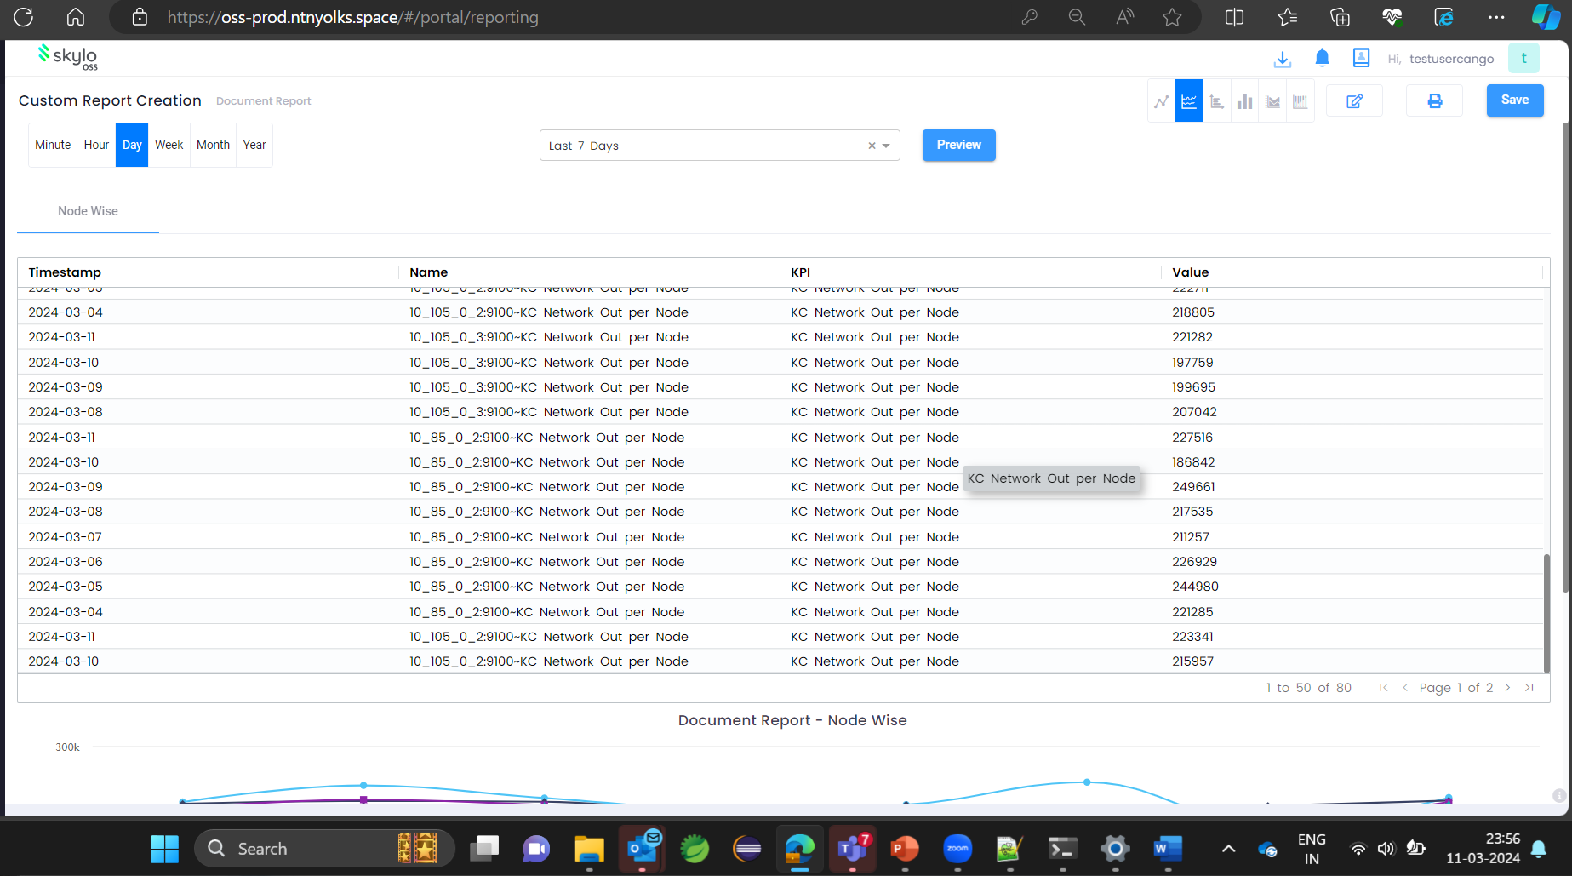

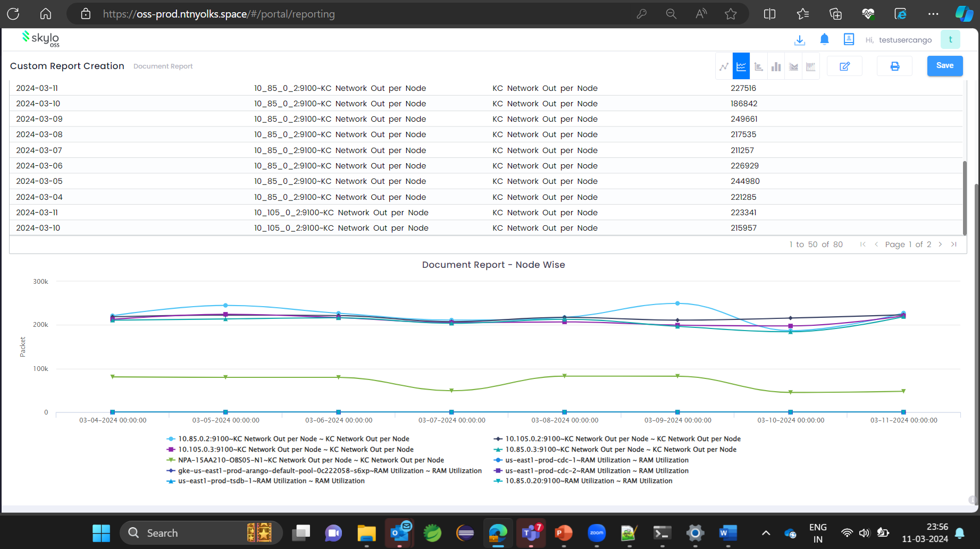

Now the created custom report is showing in the assigned folder . Now this report is ready for scheduling

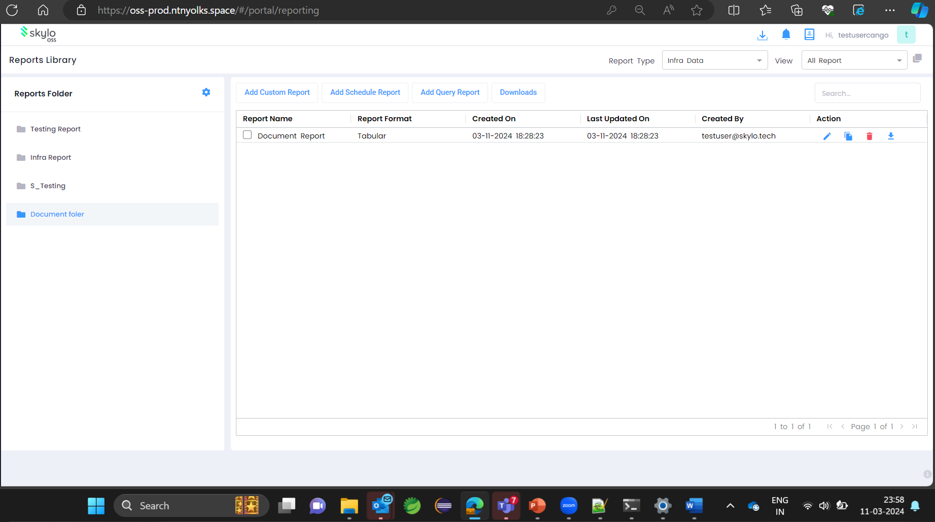

For scheduling the created report click on add schedule report

Now we can simply give that the time and we can customize it whether we we have to get the data hourly or daily or whether it is in the CSV or any other format we wish.

So if we give all the prerequisites things and the proper email ID the configured report will be received via email

