SR 2x2 switch

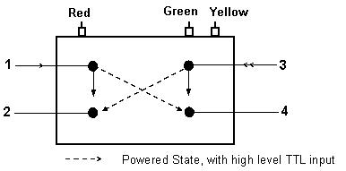
CAUTION: Thisdevice can be damaged by electrostatic discharge (ESD). Please follow standardESD procedures for handling and installation.

Direct Drive operation

Operating Instructions:

1. Connect GREEN pin to Ground.
2. Connect RED pin as follow:

Optical Connection | Red Pin
1 - 2 / 3 - 4 | --------
1 - 4 / 3 - 2 | 5V

Note: Typical Operating Current: 50 mA. Operating voltage is +5VDC ±5%.

Operating Instructions:

Note: This device can be damaged by connecting it incorrectly.
1. Connect GREEN pin to Ground.
2. Connect RED pin to +5 VDC ± 5%.
3. Connect YELLOW pin as follows:

TTL Drive operation

Optical Connection | TTL Input Level (yellow pin)
1 - 2 / 3 - 4 | LOW
1 - 4 / 3 - 2 | HIGH
TTL logic high: (2.0 ≤ HIGH ≤ 5.25 V)
TTL logic low : (0 ≤ LOW ≤ 0.8 V)
Typical Operating Current: 25 mA plus 50 mA when port 1 selected.

