Steps to troubleshoot CleanBlast™ that is spraying contamination/leaving residue:

- Prime the unit. A unit should be primed if:
  - The solvent has just been refilled (5-7 long prime cycles)
    - NOTE: Do not overfill the solvent tank, meaning do not fill if the LOW SOLVENT light is not on
    - If the tank has been overfilled, you may have to prime 50 or more times to clear enough solvent for CleanBlast to be able to properly pressurize
  - The unit has been off for more than 12 hours (5-7 prime cycles)
  - The unit has been off for a week or longer (perform “door open prime”—see steps on next page)
  - The unit has been moved or shipped (perform “door open prime”—see steps on next page)
- Check the exhaust circuit on the handset
  - Make sure the unit is powered OFF (unplugged from AC power is ideal)
  - Remove the tip from the handset nozzle, if attached
  - Look at the handset nozzle. You will see a small circular opening and a larger, crescent-shaped opening below it. The small circular opening is the solvent delivery nozzle. The larger crescent-shaped opening is the exhaust circuit.
  - If the exhaust circuit is blocked, use a paper clip or similar device to gently remove any blockage
  - Run 7-10 prime cycles to flush the lines after clearing the blockage
- Issues with tips
  - If the nozzle on the tip is bent or damaged, discard it and order a replacement (it is not economical to repair tips)
  - Tips can sometimes harbor contamination which may spray onto the end face during cleaning. Tips can become dirty if they are left out exposed to the air for several days. To clean a tip, place it in an ultrasonic bath. A small ultrasonic bath can be purchased for a nominal amount from companies such as Cole-Parmer or other laboratory supply firms.
- Replace the internal filters
  - CleanBlast filters the air before spraying it on an end face. These filters should be replaced every 100,000 cycles or every 6-12 months, whichever comes first.
  - Each CleanBlast includes a counter that monitors the number of cleaning cycles that have been performed. When it reaches 100,000, the SERVICE light will come on, indicating it is time to replace the filters.
  - Instructions for replacing the filters are in the user manual
- Benchtop-specific issues (FCL-Bxxxx)
  - The minimum air input is 100psi. Previously Viavi had recommended 60psi. Our documentation is in the process of being updated currently.
  - If multiple units are connected to the same compressor, those at the end of the line may not receive sufficient air to fully perform cleaning. If you have more than 3 units connected to a compressor and only those at the end of the line are not performing well, swap them with those at the front of the line and see if the problem persists. If it does, insufficient air is the cause—another compressor (or nitrogen) will be necessary. If the issue stays with the unit regardless of whether it is at the front or end of the line, then another issue exists
- If all else fails, return the unit to Viavi for service

Door Open Prime Instructions

- Turn unit ON
- Open solvent refill door (see Figure 1). You will hear a hissing sound as the tank decompresses.
- Block the handset nozzle
  - Only the solvent delivery nozzle (circular opening) needs to be covered—do NOT block the solvent exhaust circuit (crescent-shaped opening)
  - Recommendation: use 2.5mm dust cap and press firmly to ensure no air escapes (see Figure 2)
- Press PRIME button twice, then the RUN button on the handset once (standard priming procedure)

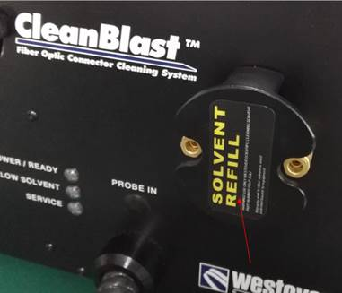
Figure 1. Open Solvent Cap

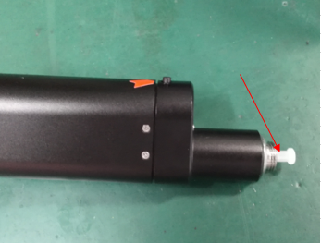
Figure 2. Dust Cap Covering Nozzle

