How Do I Download and Install TrueSite Play?

If you have Android OS 4.2 or higher on your phone, and a Google account, you can download and install Truesite Play from the Google Play Store.

If you type in Truesite Play and see nothing under Apps (like I did), tap the little magnifier “search” button in the extreme lower right of the screen:

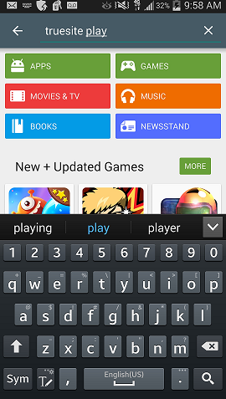

Then you will see this!

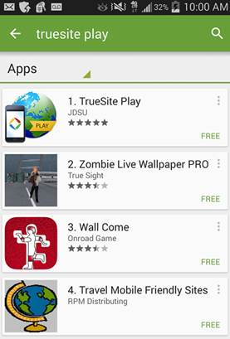

Tap on TrueSite Play and install:

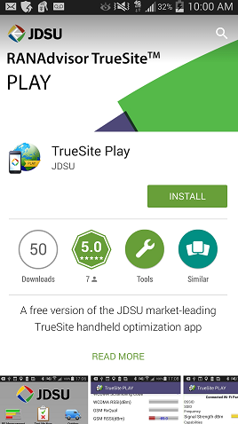

If you click on Help Videos, you will get a screen by screen walkthrough of TrueSite. Under About, there is a list of phone numbers by region and a website if the user wants to get the full version.

